**COMP229 ASSIGNMENT 2: NODEJS ENDPOINTS**

**R MARCO AURELIO DOMINGUEZ SANTANA**

**Contents**

1 Contacts endpoints 2

1.1 Get contact by id 2

1.2 Get all contacts 3

1.3 Add new contact 4

1.4 Update contact by id 5

1.5 Remove contact by id 6

1.6 Remove all contacts 7

2 Projects endpoints 8

2.1 Get all projects 8

2.2 Get projects by Id 9

2.3 Add new projects 10

2.4 Update project by id 11

2.5 Remove project by id 13

2.6 Remove all projects 14

3 Services endpoints 15

3.1 Get all services 15

3.2 Add new service 15

3.3 Get service by id 16

3.4 Update service by id 17

3.5 Remove service by id 19

3.6 Remove all services 20

4 Users endpoints 21

4.1 Get all users 21

4.2 Get User By Id 22

4.3 Add new user 23

4.4 Update user by id 24

4.5 Remove user by id 25

4.6 Remove all users 26

# Contacts endpoints

## Get contact by id

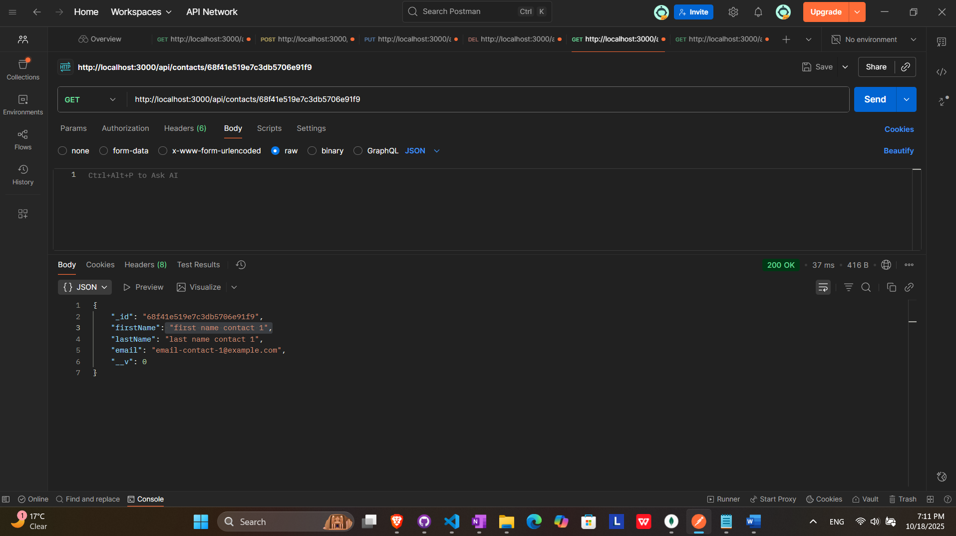

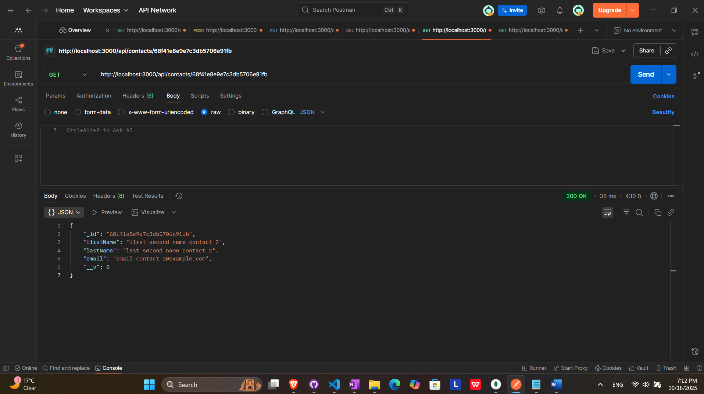

## Get all contacts

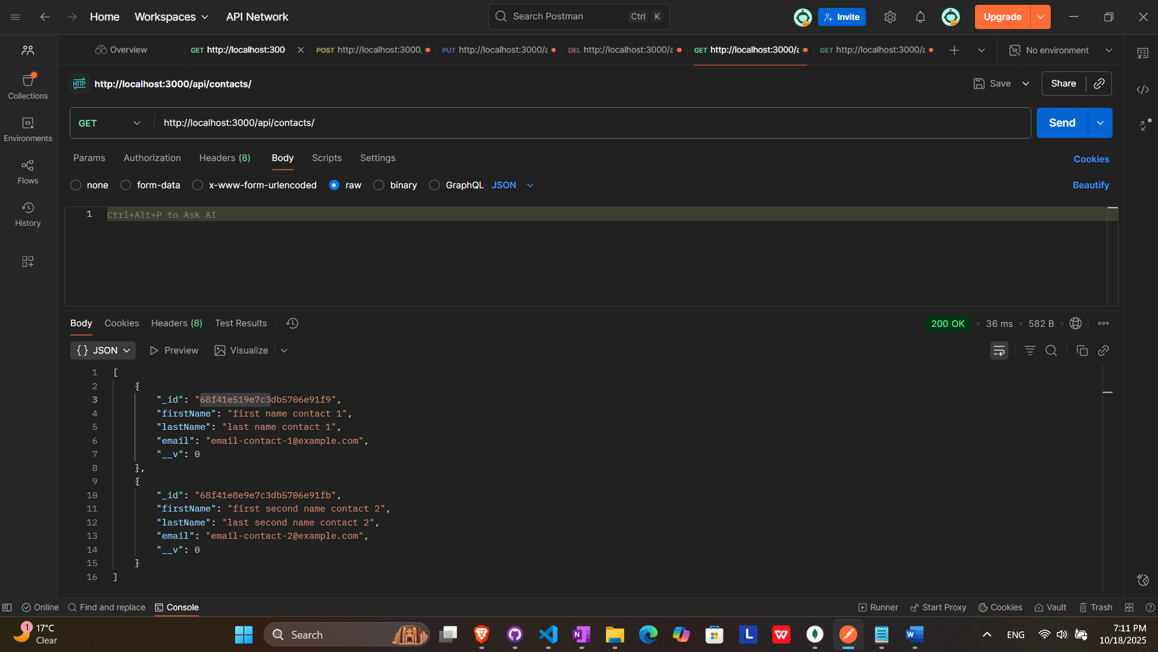

## Add new contact

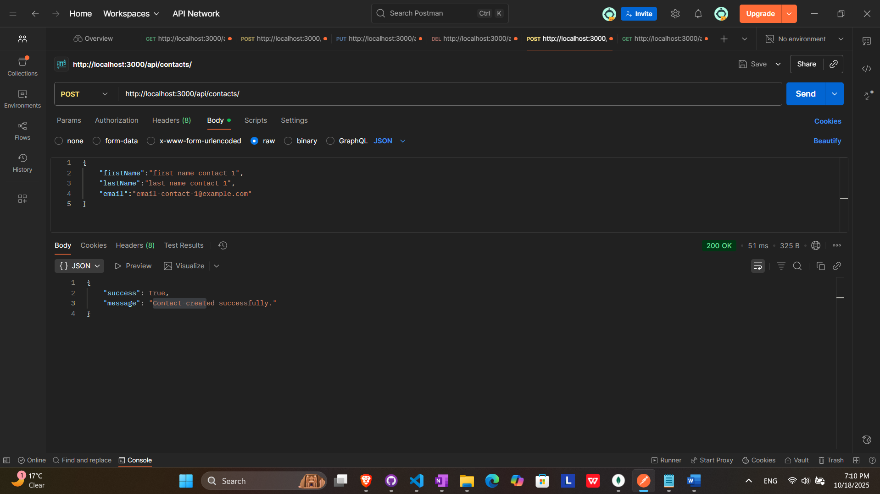

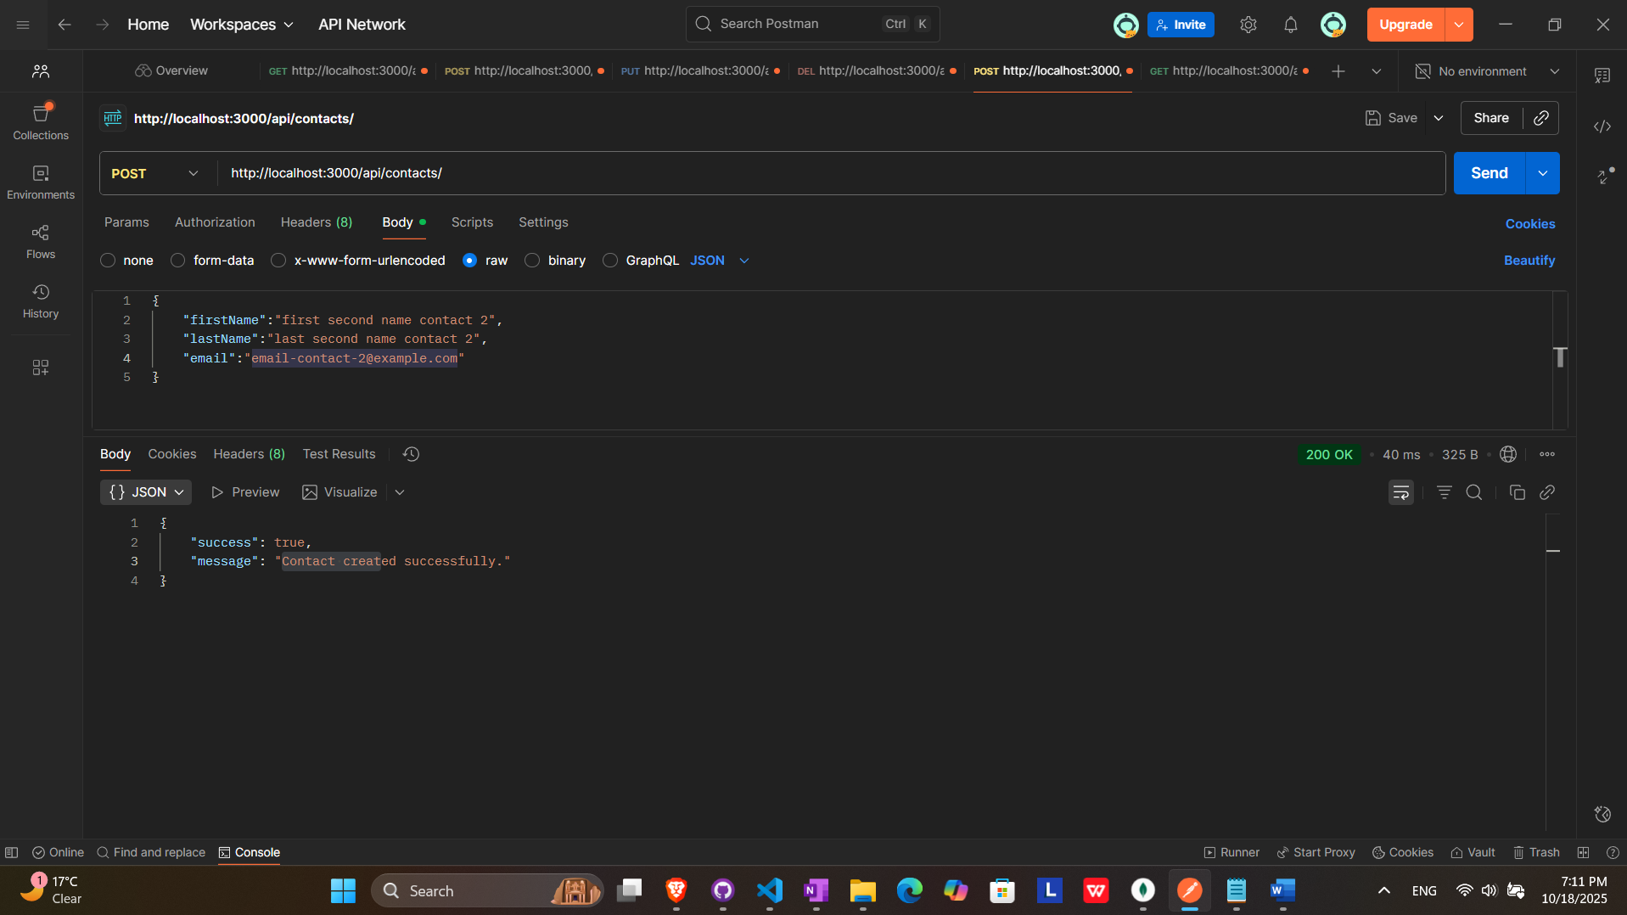

## Update contact by id

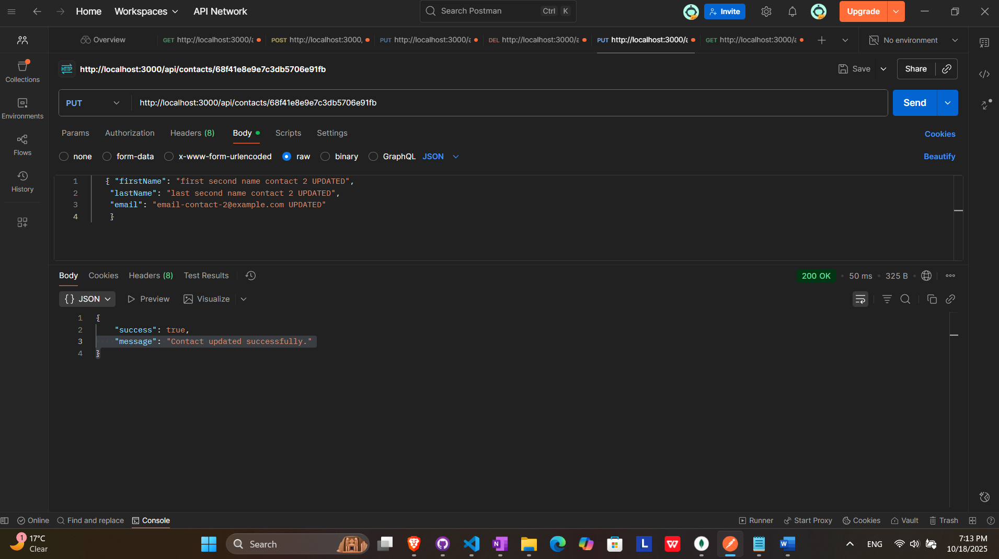

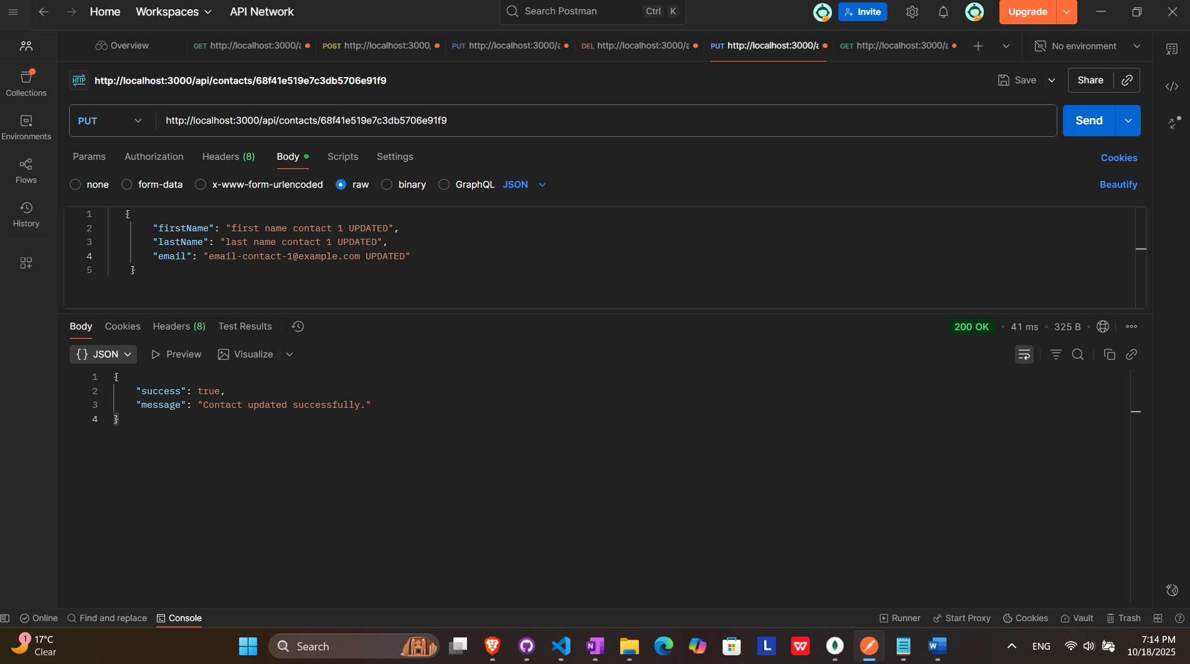

RESULT (UDPATED CONTACTS)

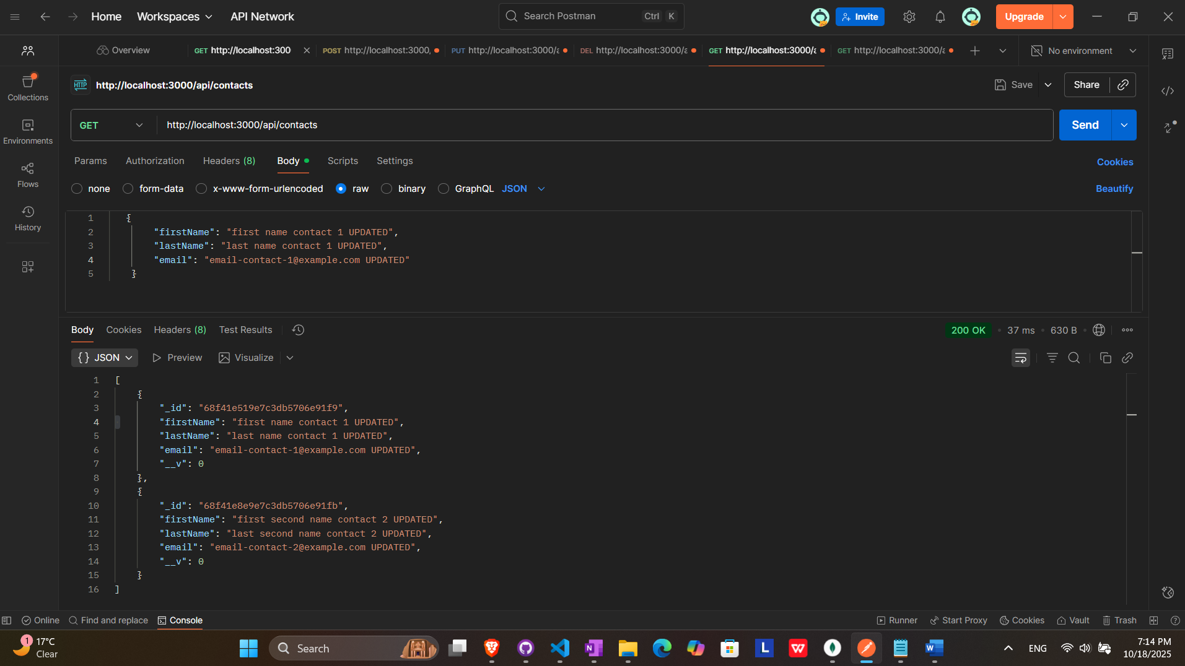

## Remove contact by id

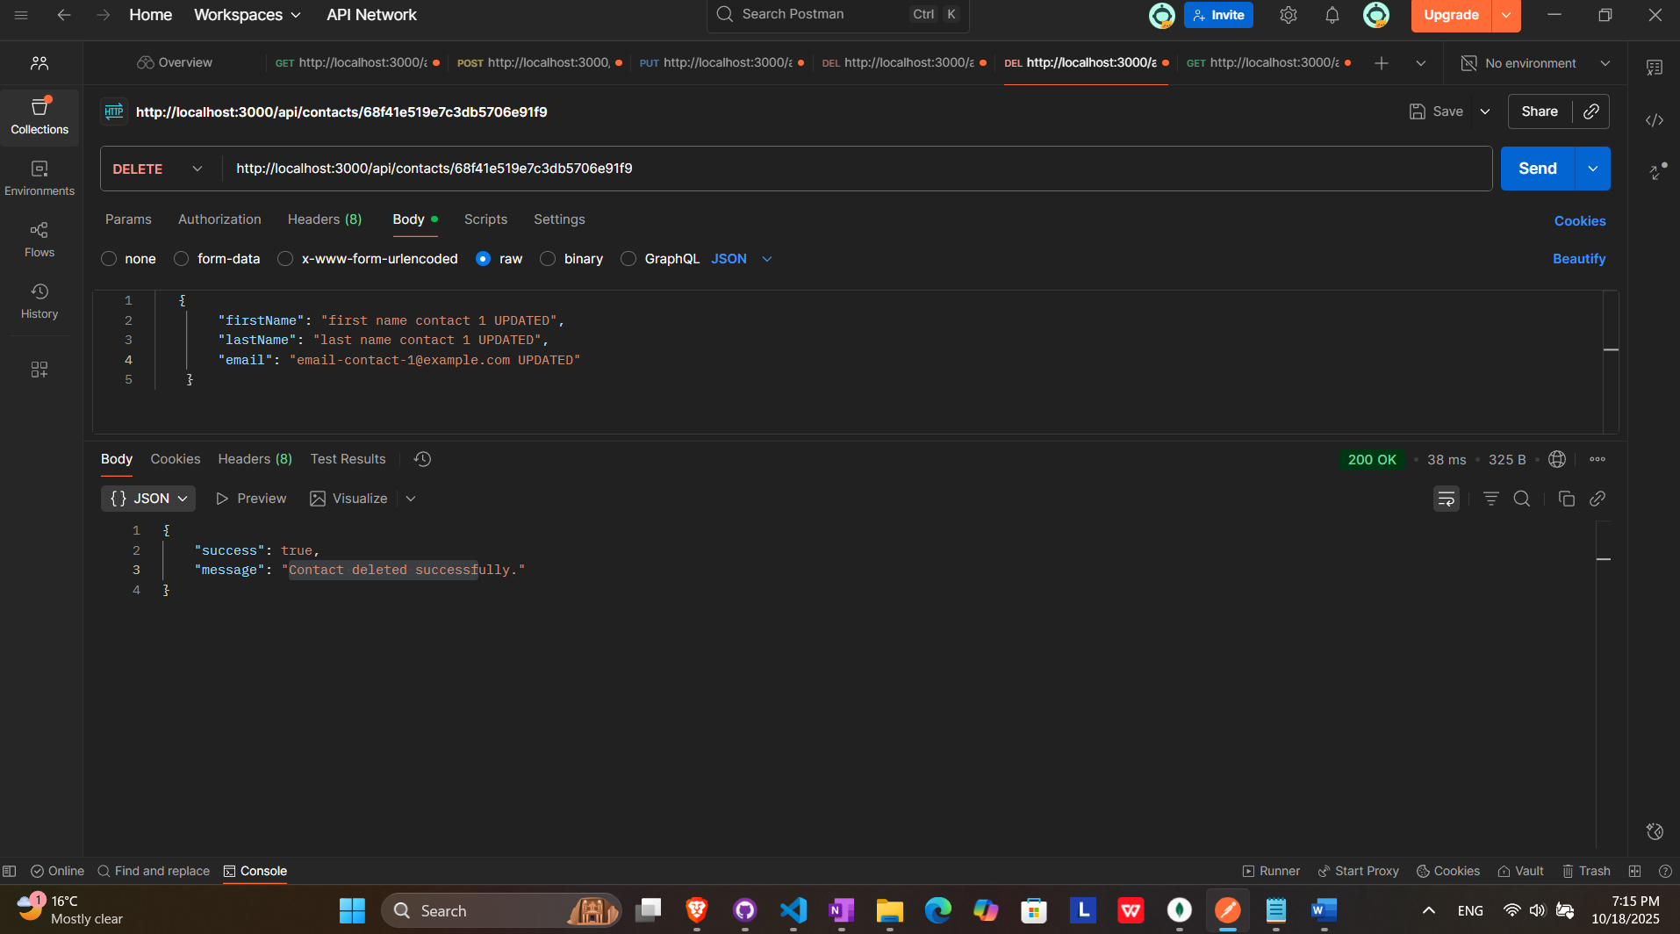

RESULT (FIRST CONTACT REMOVED)

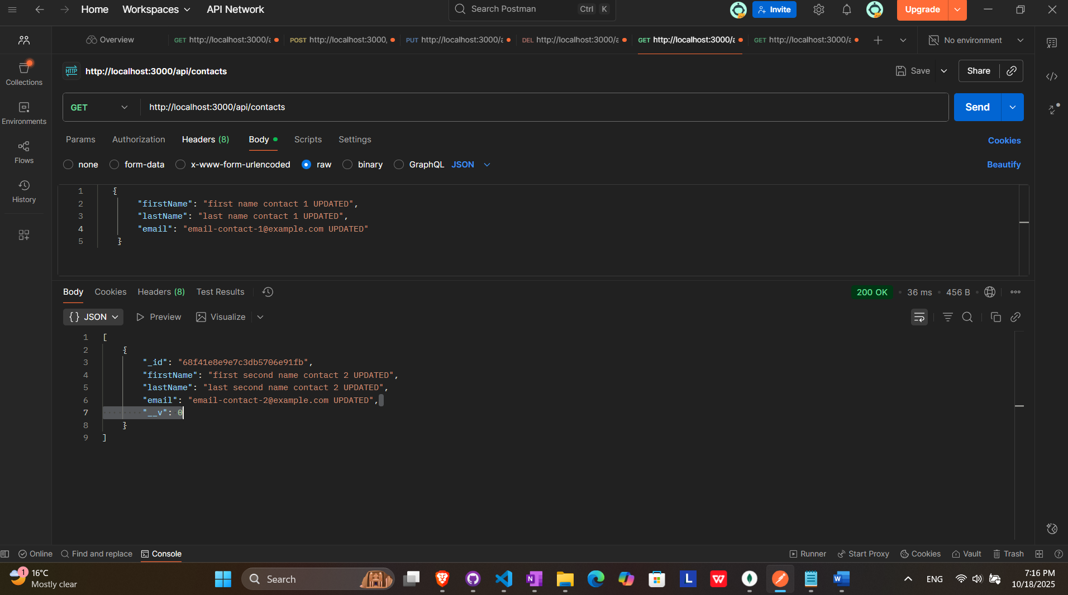

## Remove all contacts

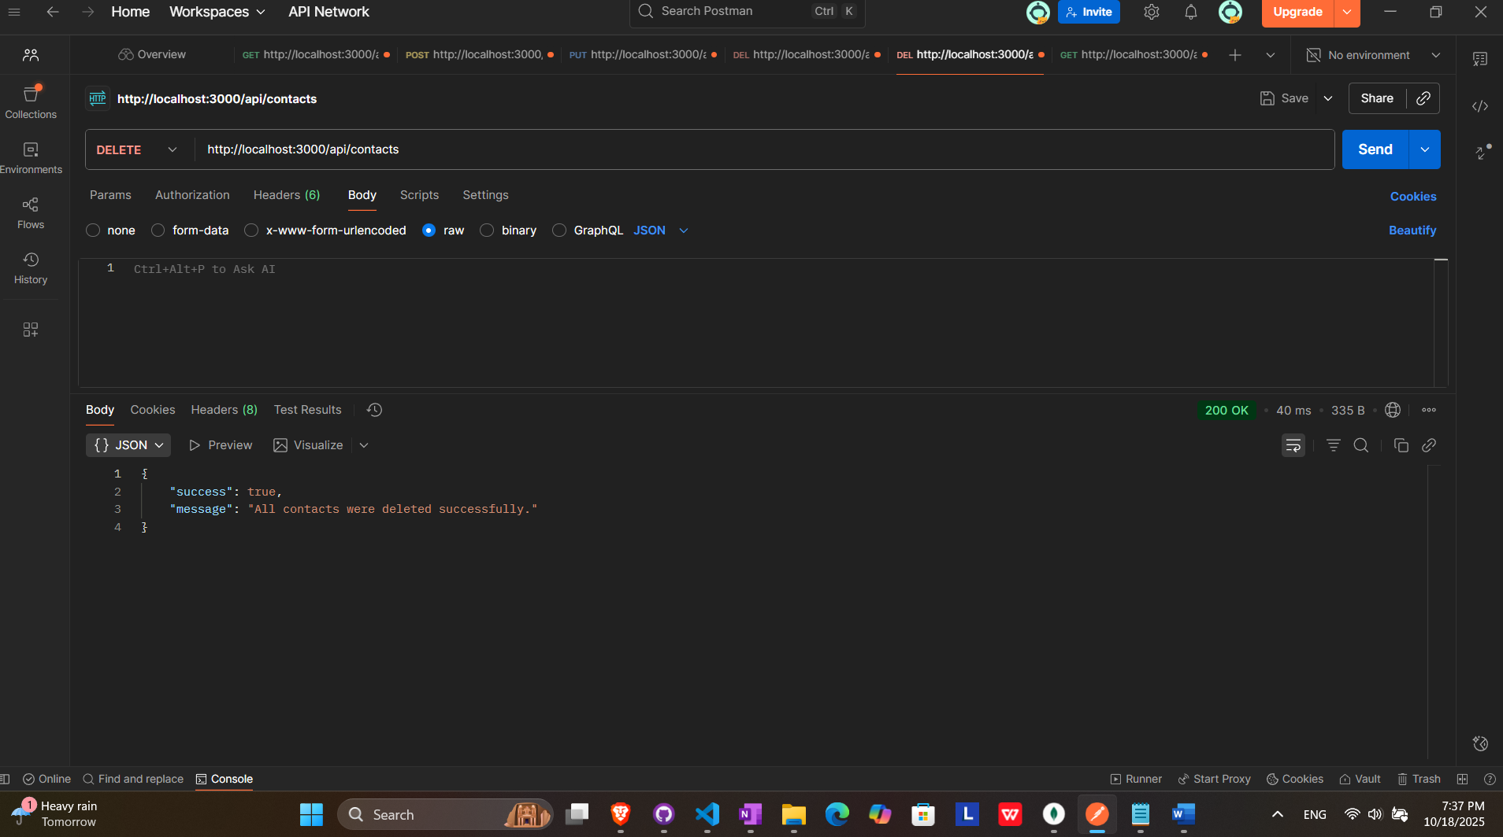

RESULTS (ALL CONTACTS DELETED)

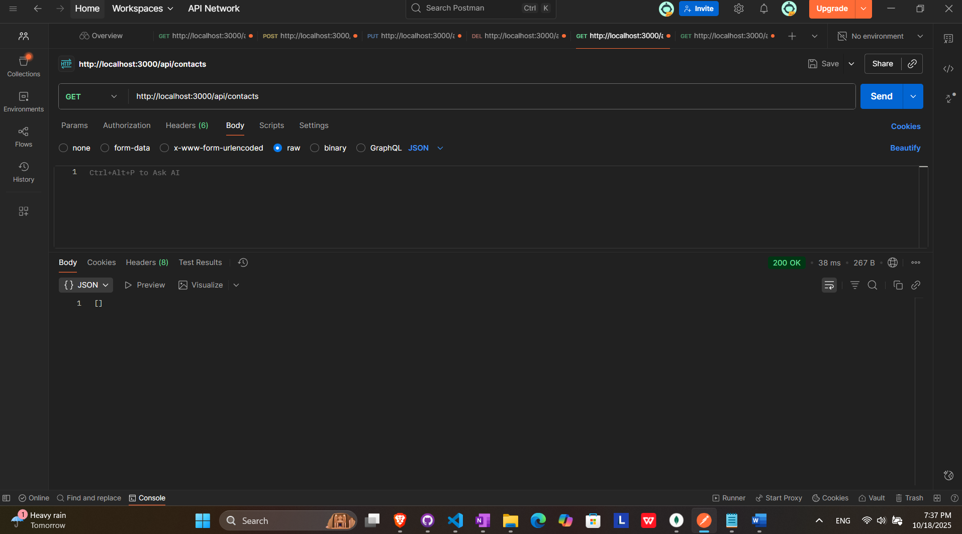

# Projects endpoints

## Get all projects

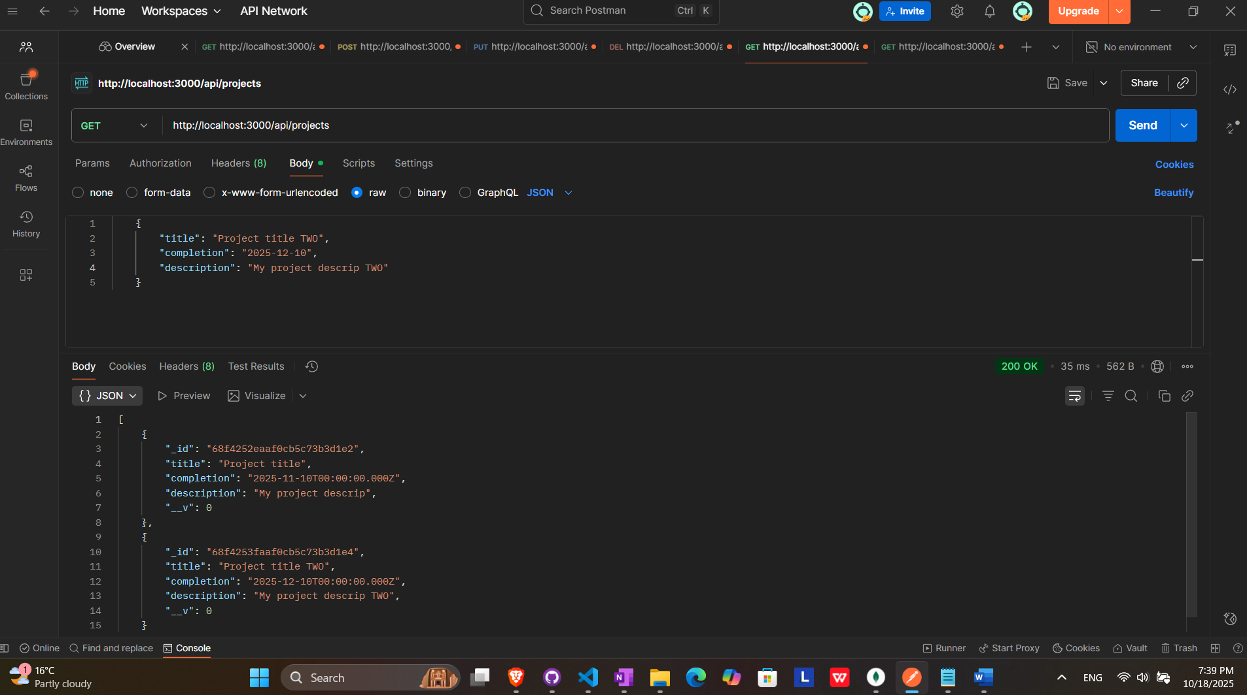

## Get projects by Id

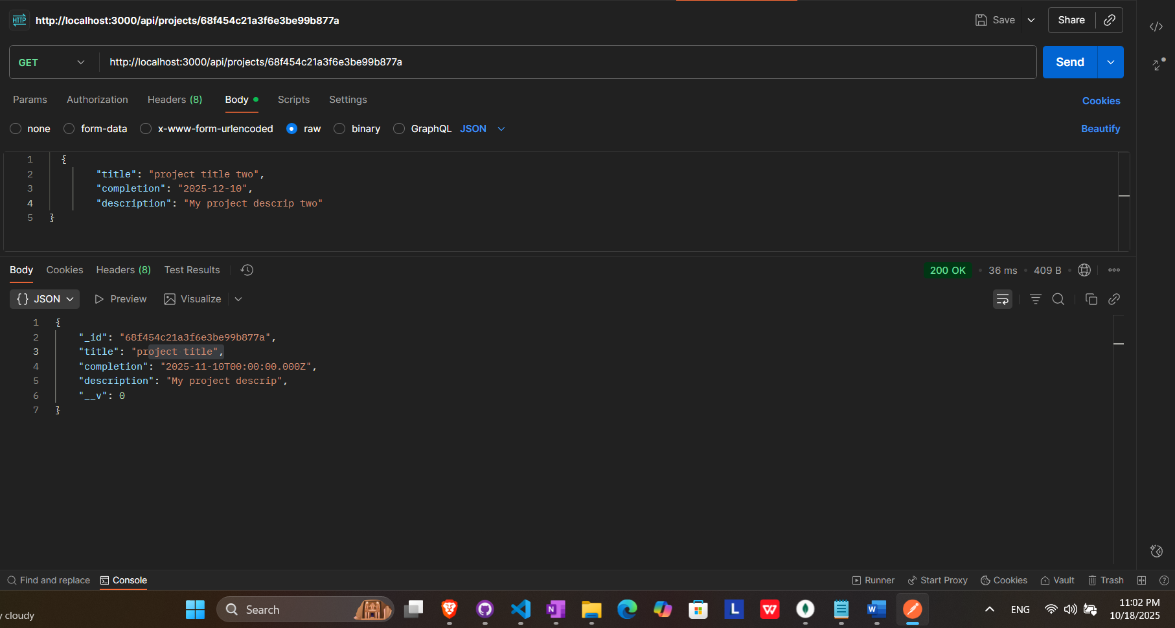

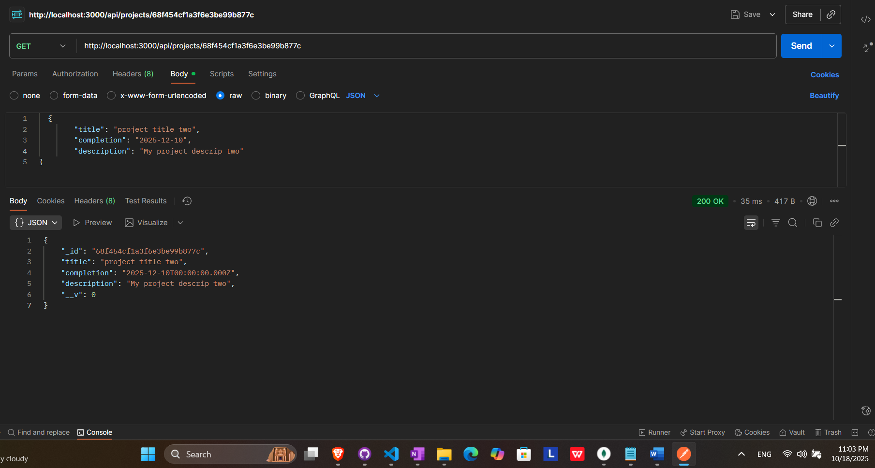

## Add new projects

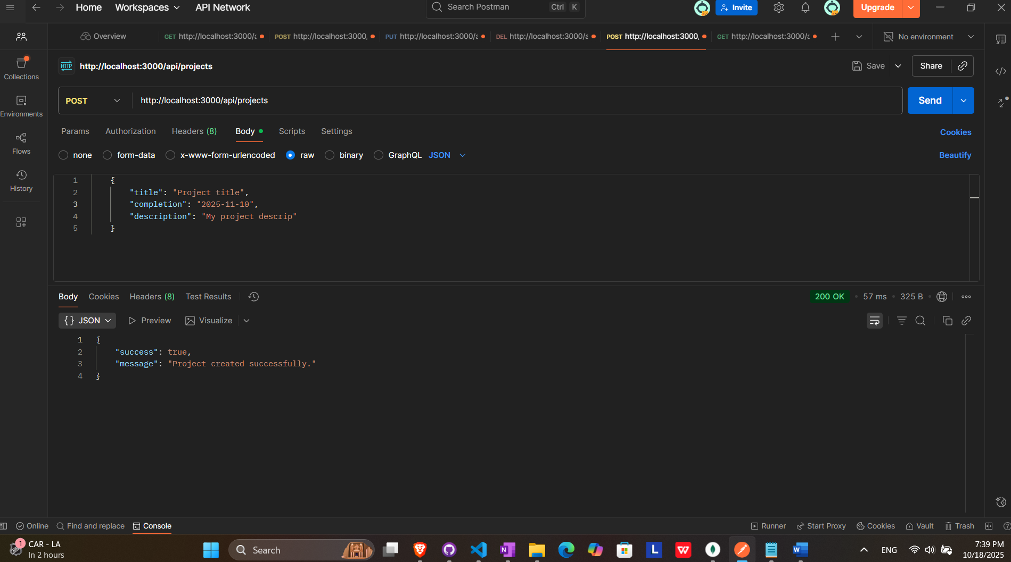

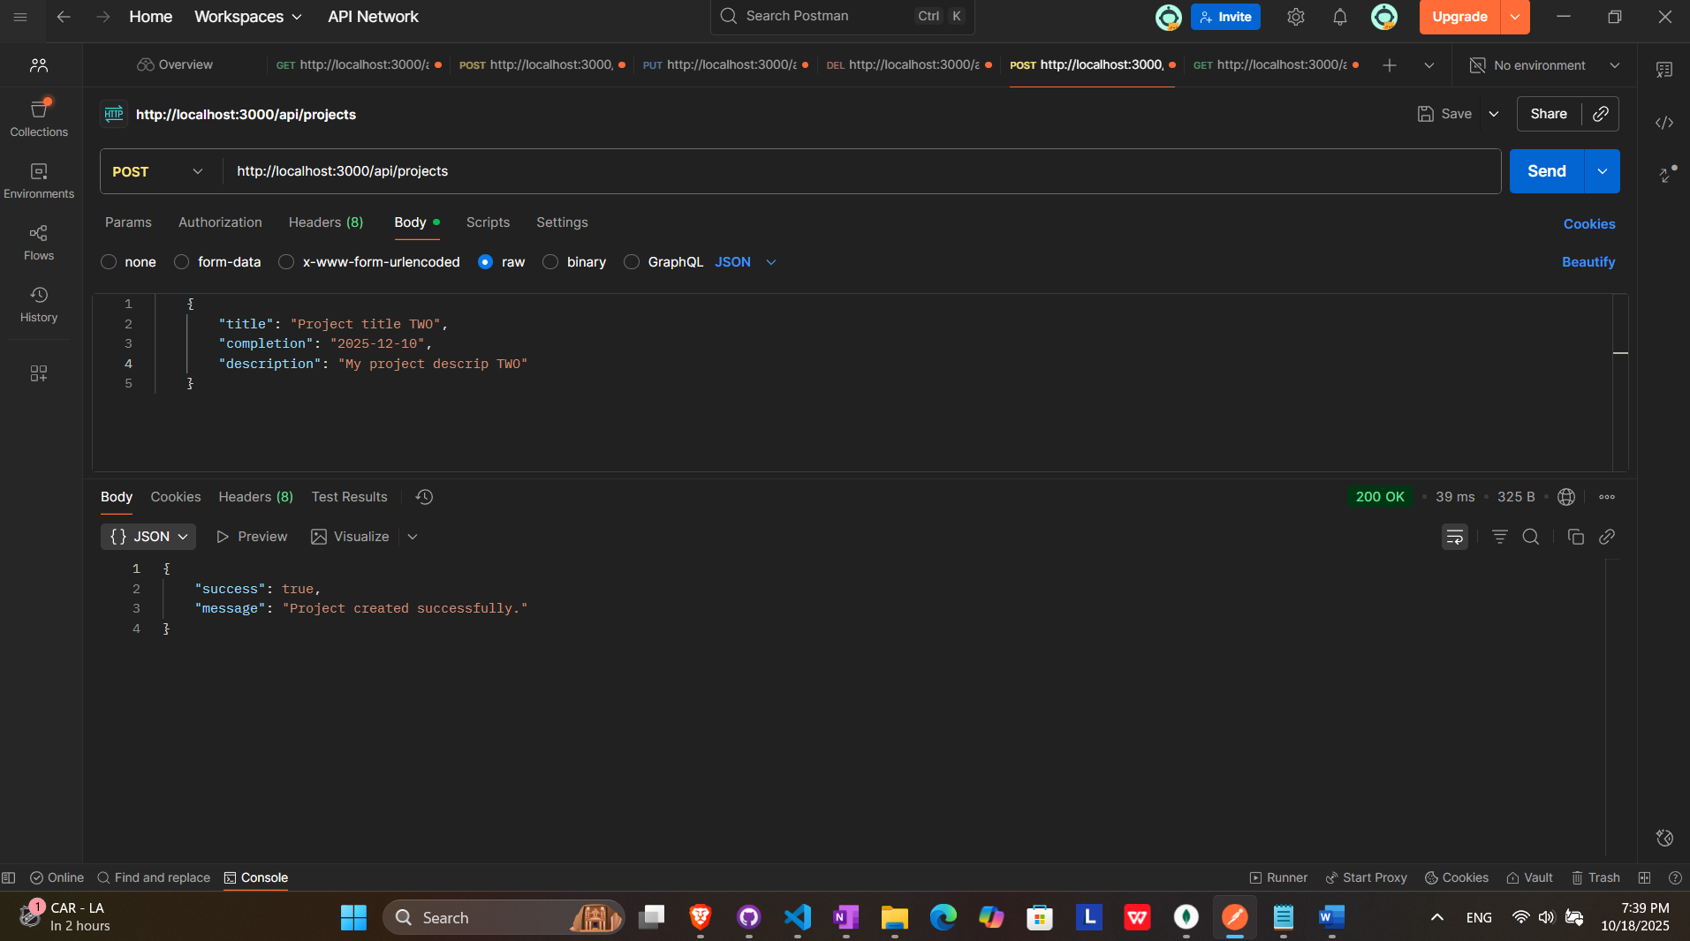

## Update project by id

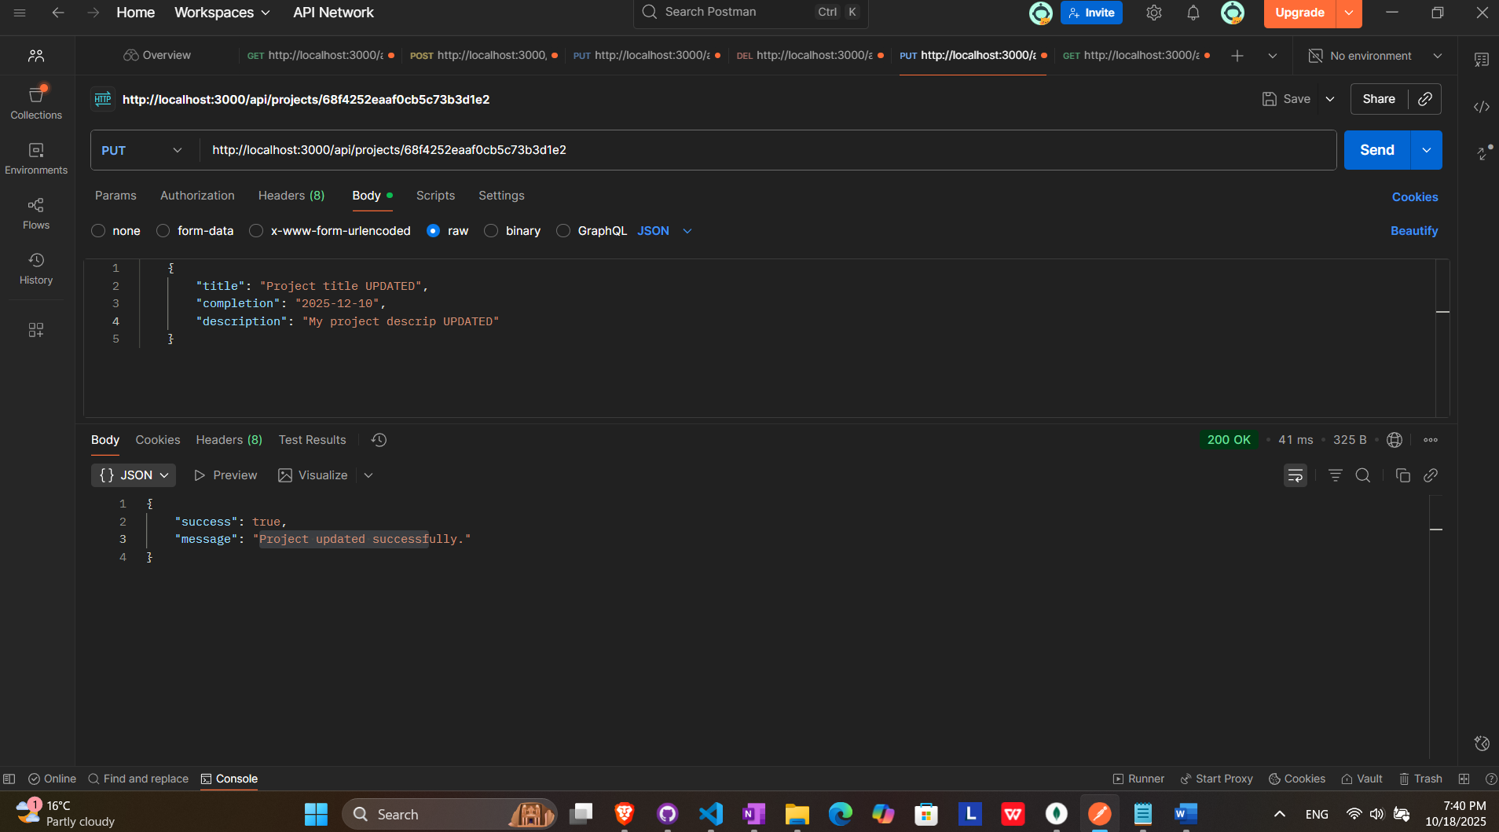

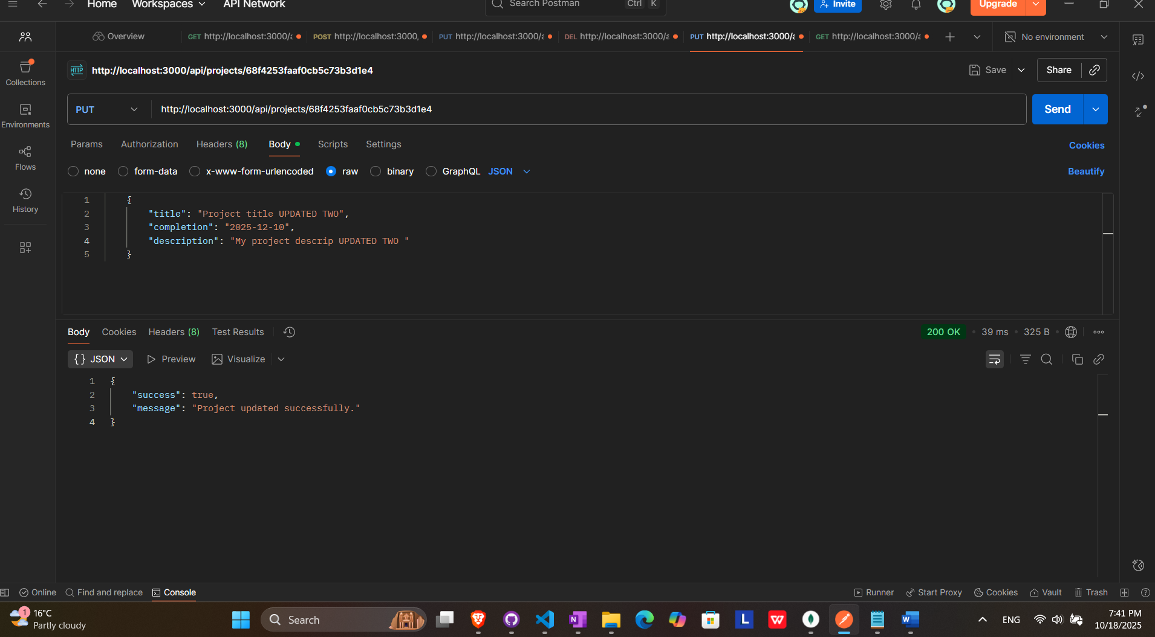

RESULT (ALL PROJECTS UPDATED)

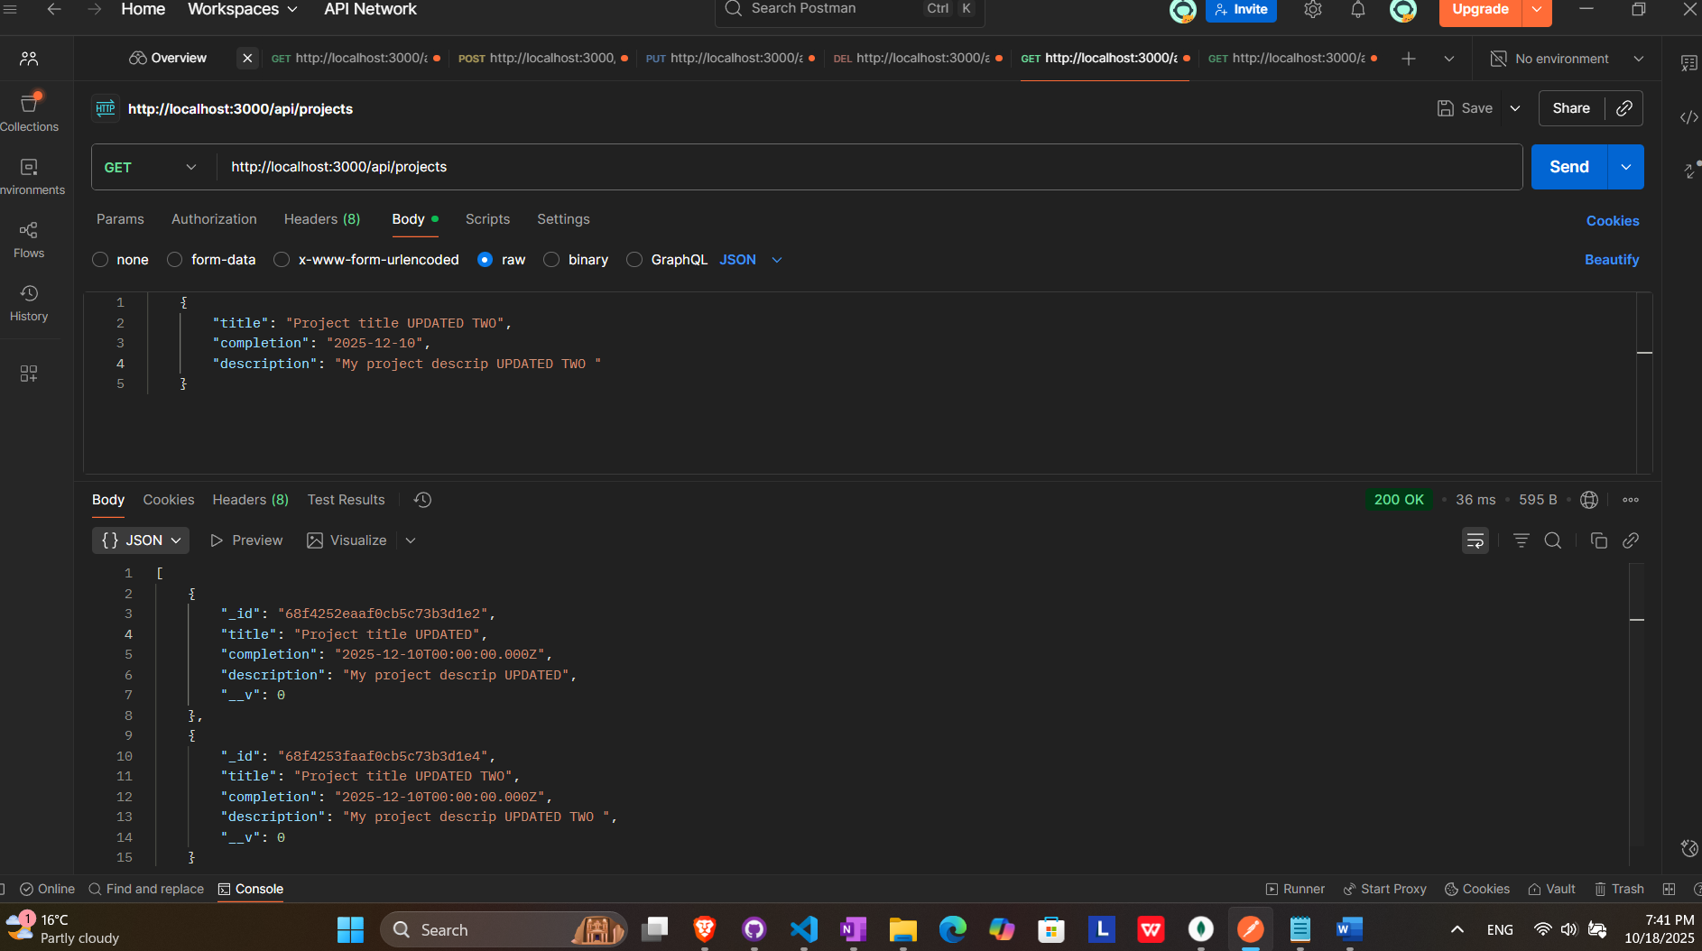

## Remove project by id

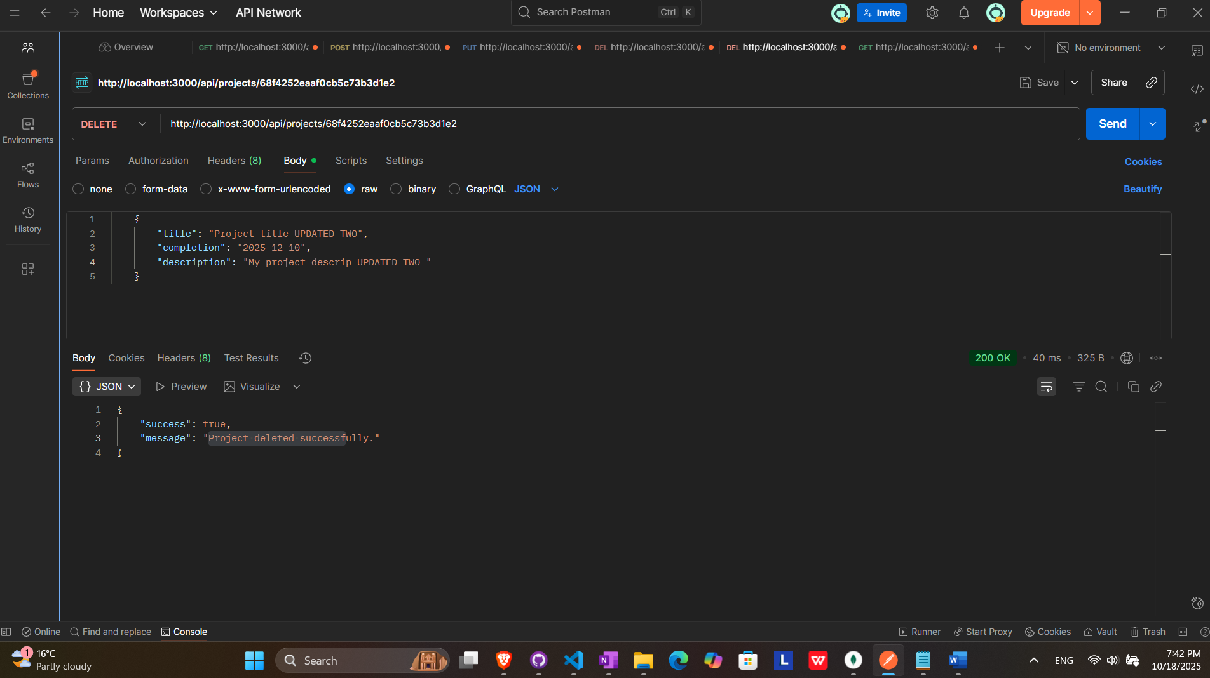

RESULT (ONE PROJECT MISSING)

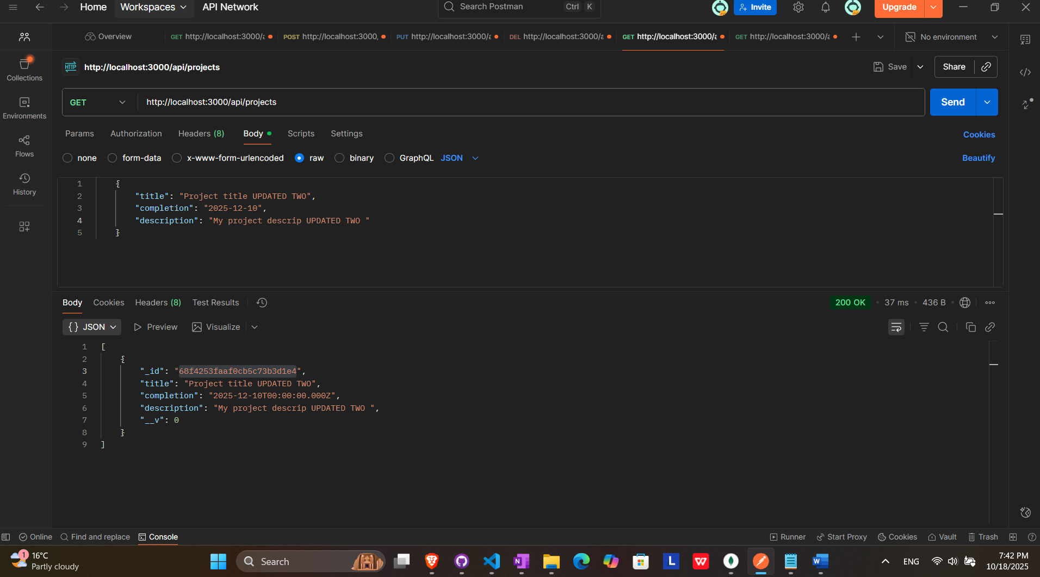

## Remove all projects

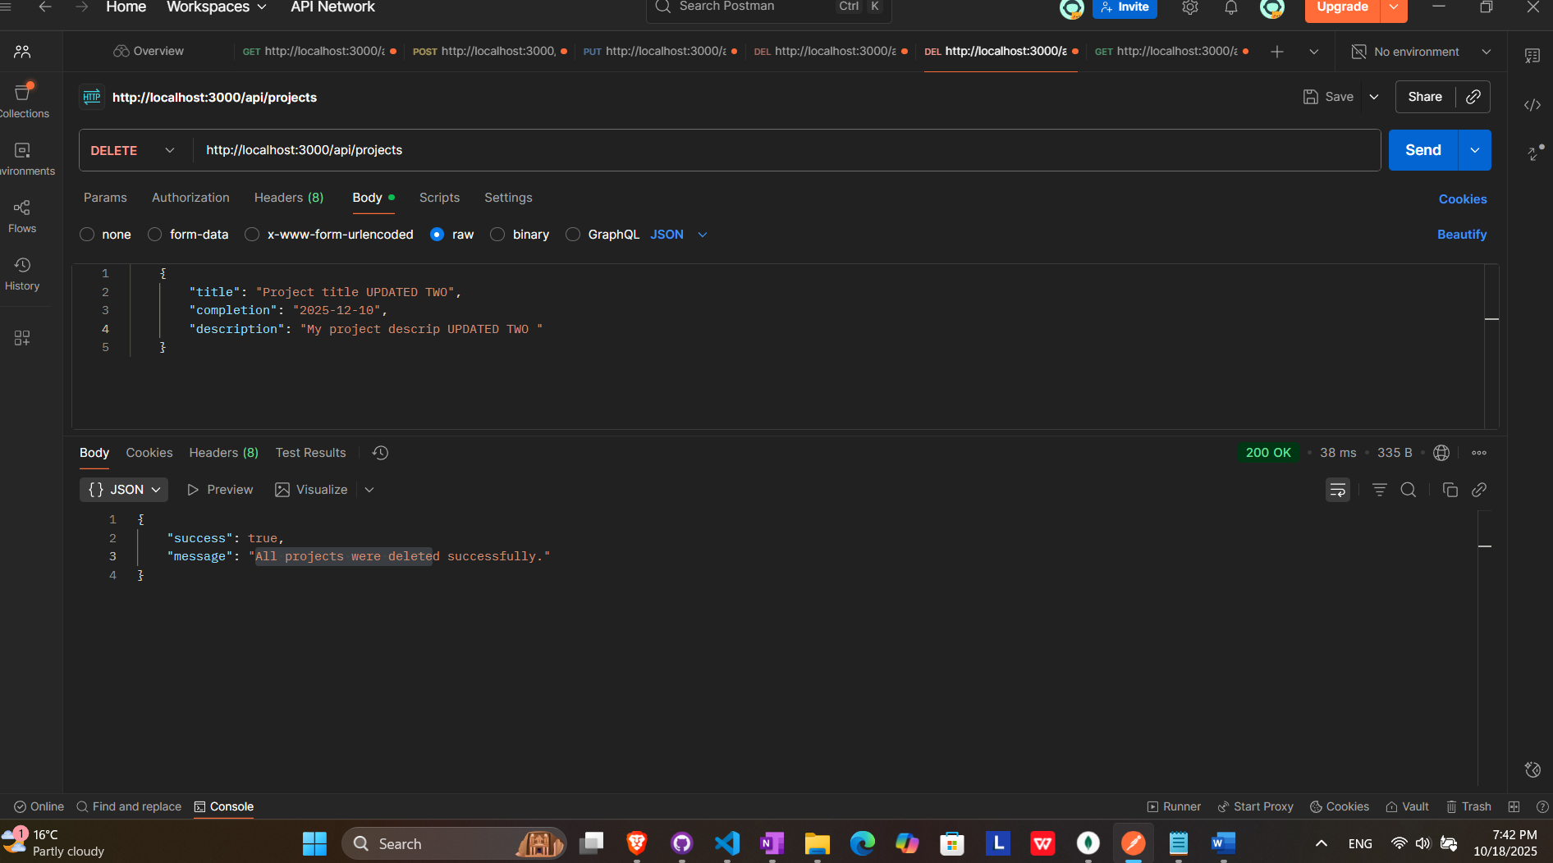

RESULT (ALL PROJECTS DELETED)

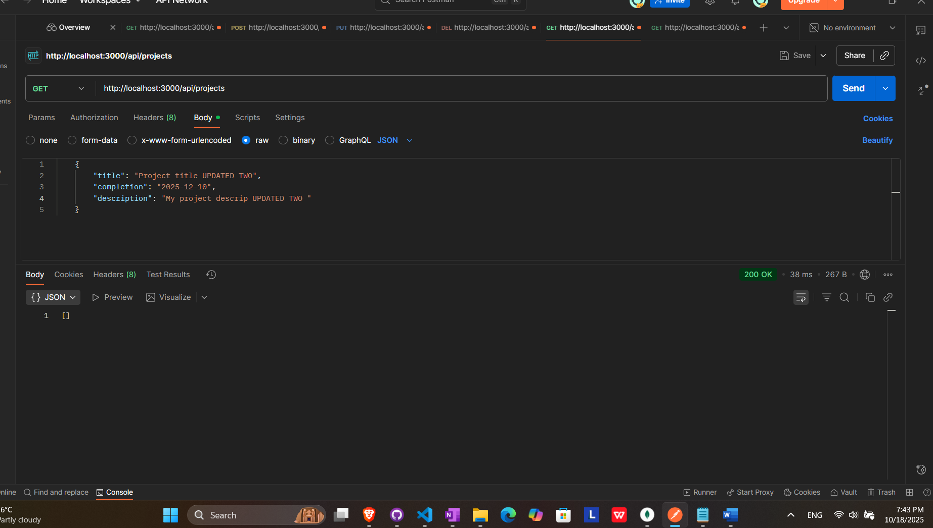

# Services endpoints

## Get all services

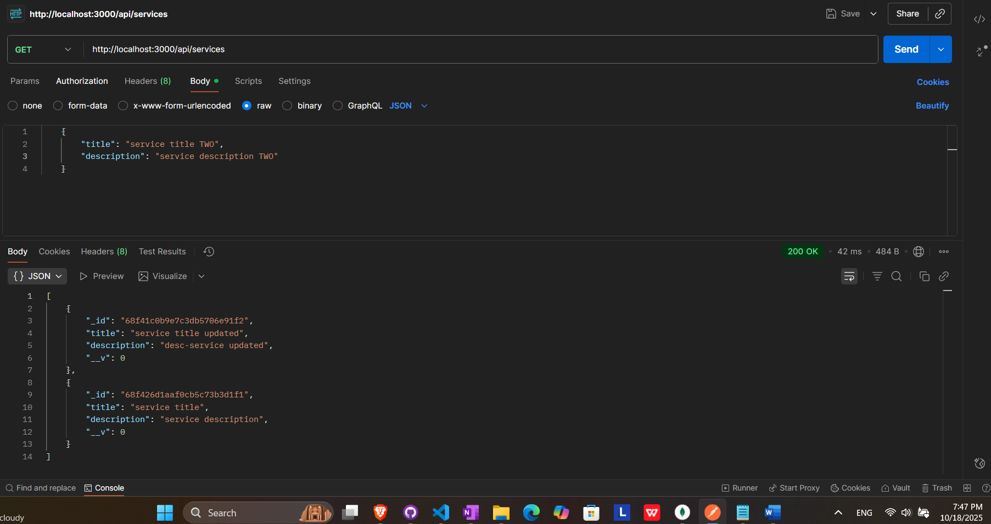

## Add new service

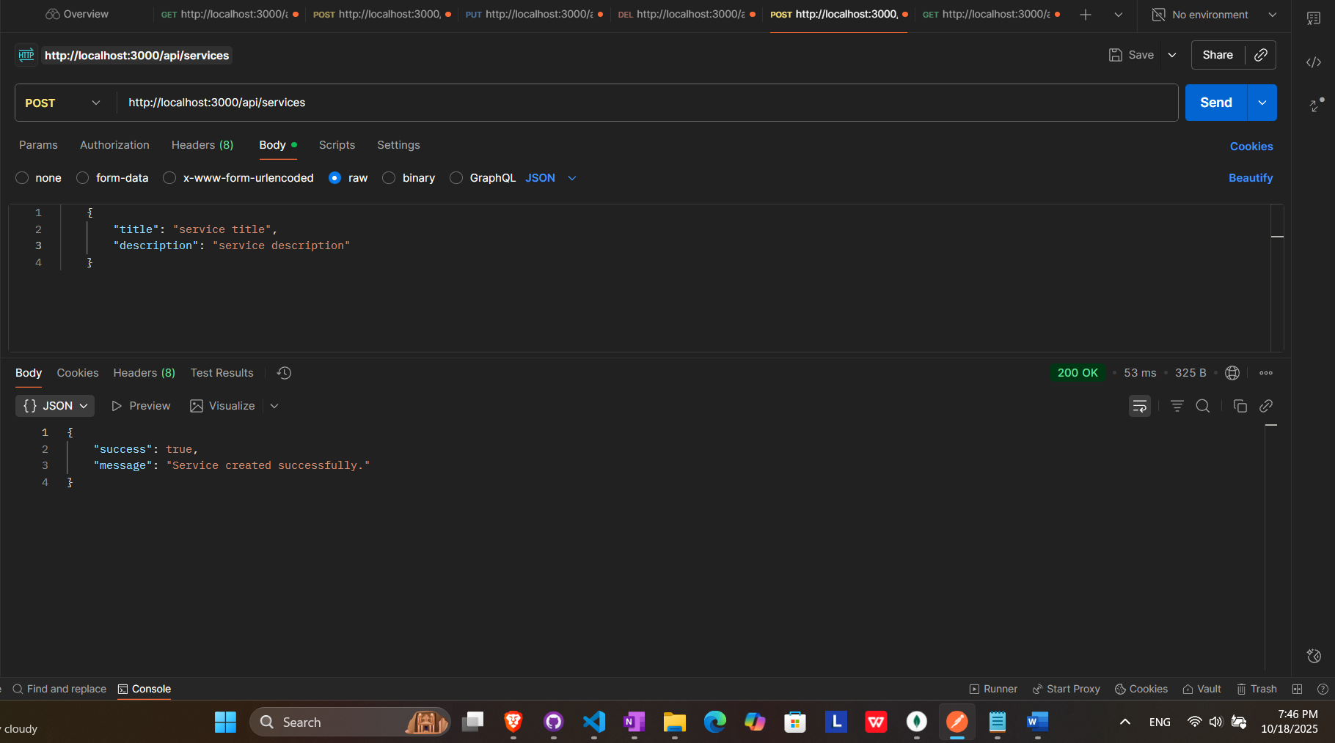

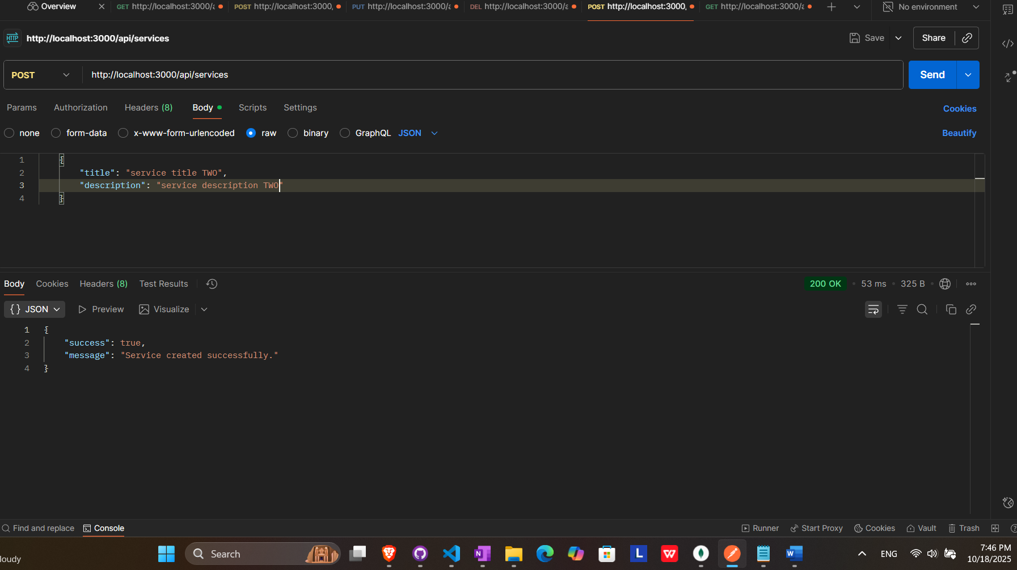

## Get service by id

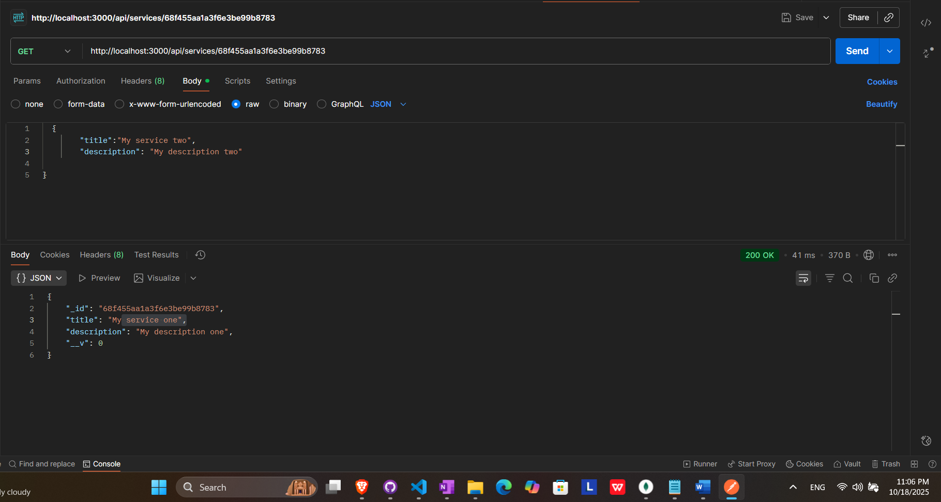

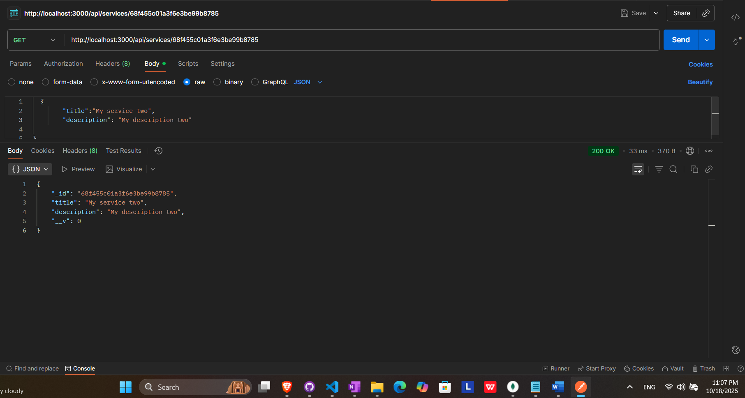

## Update service by id

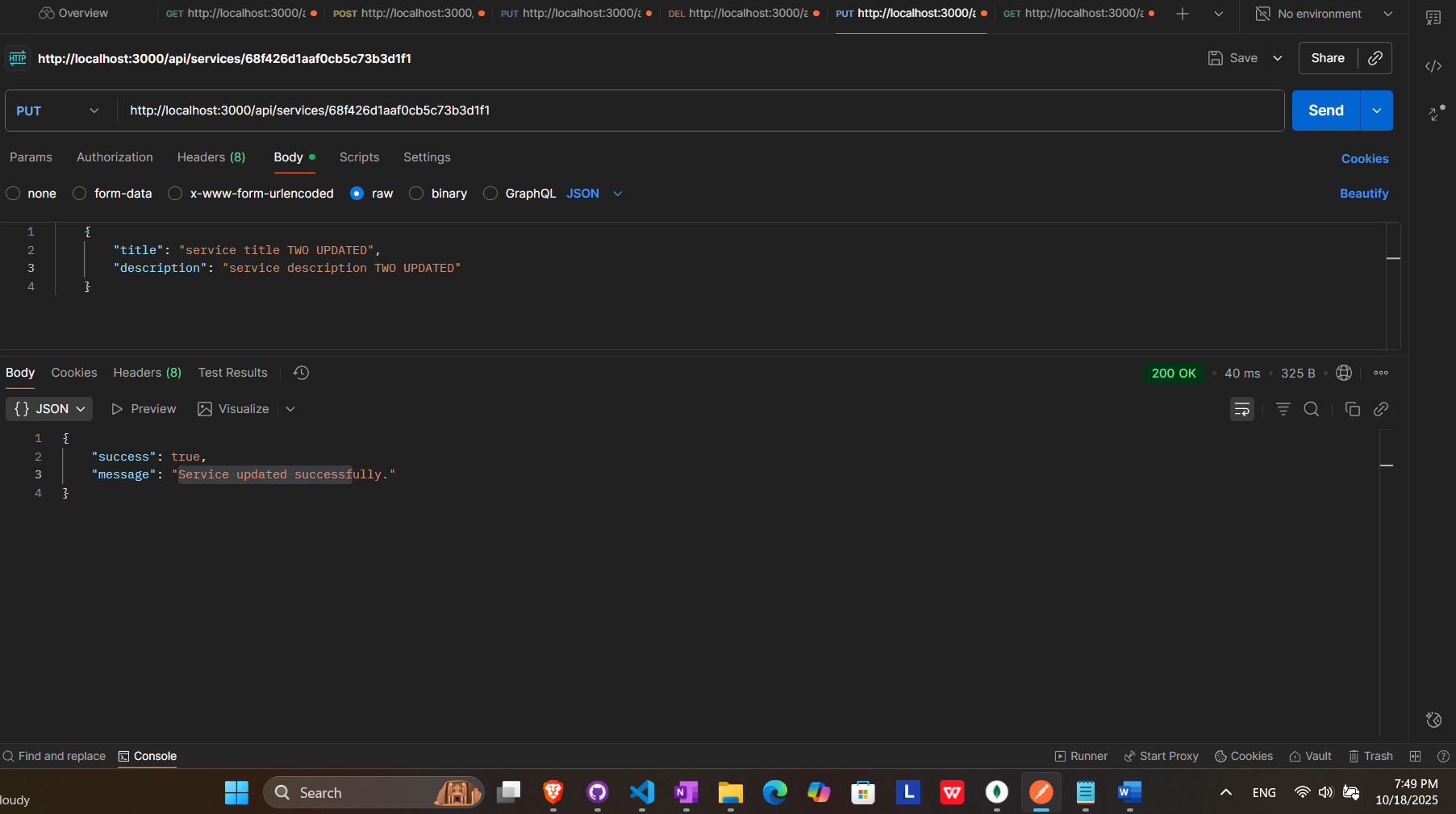

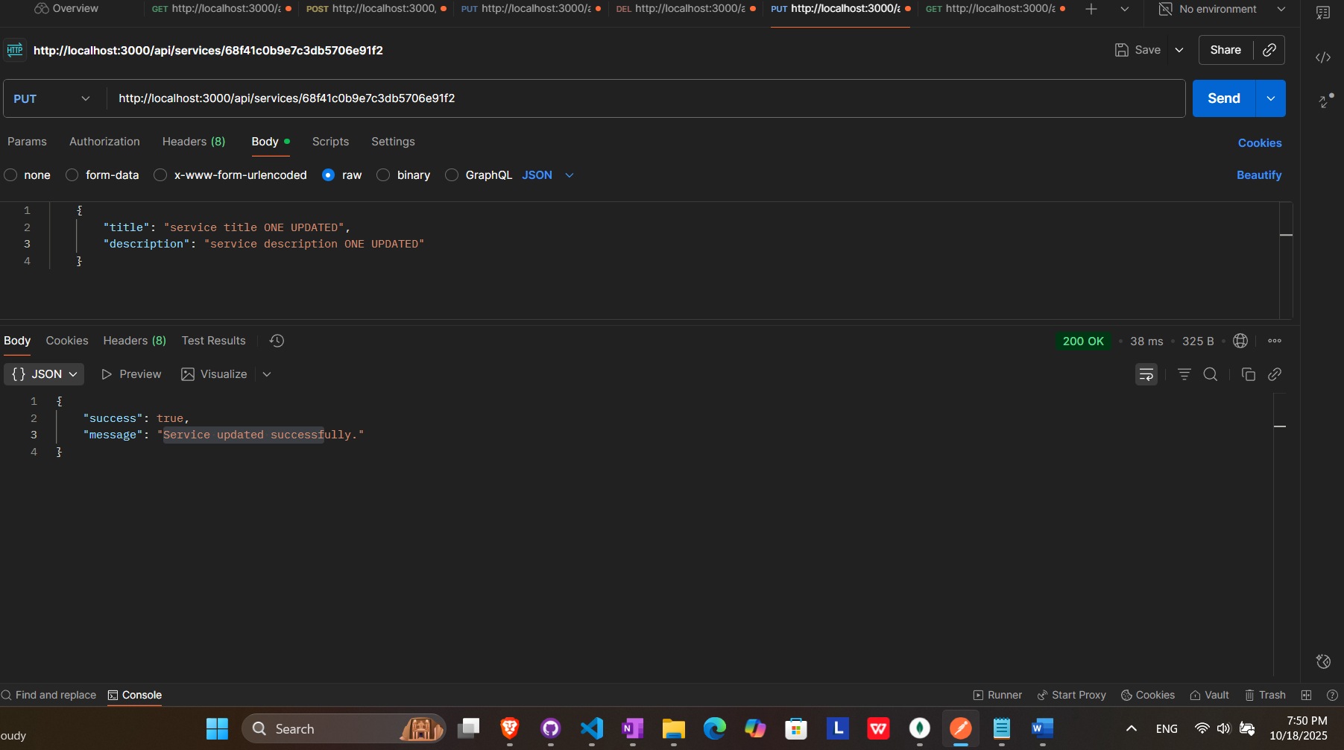

RESULTS (SERVICES UPDATED)

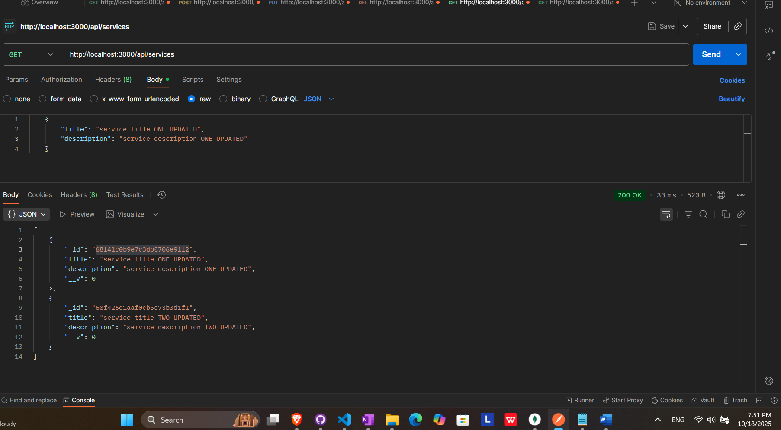

## Remove service by id

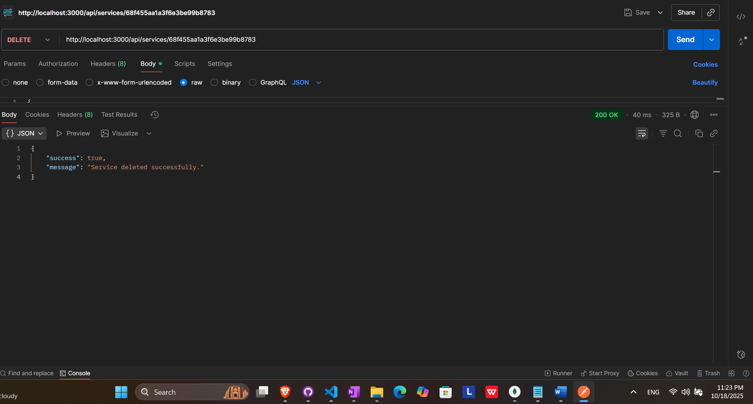

RESULT (SERVICE DELETED)

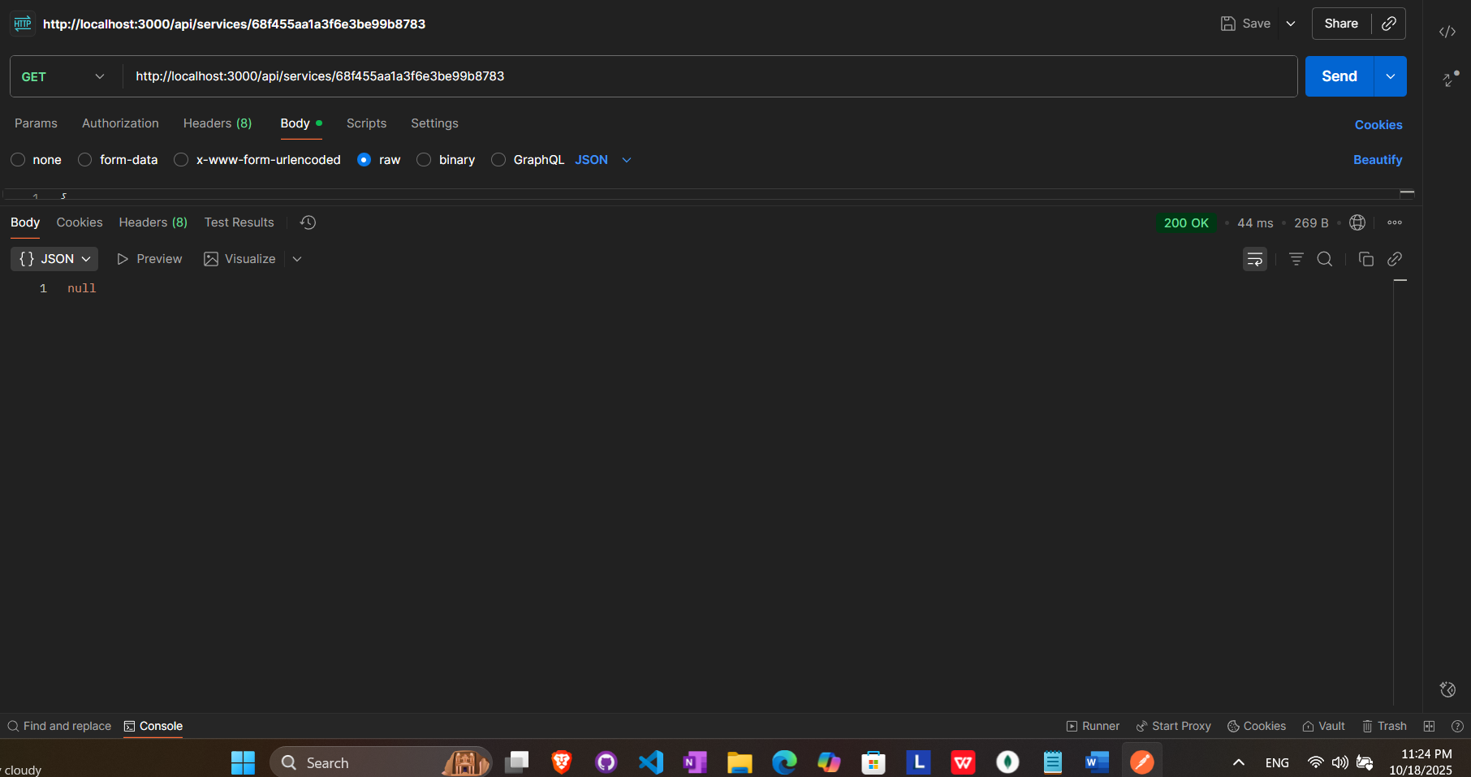

## Remove all services

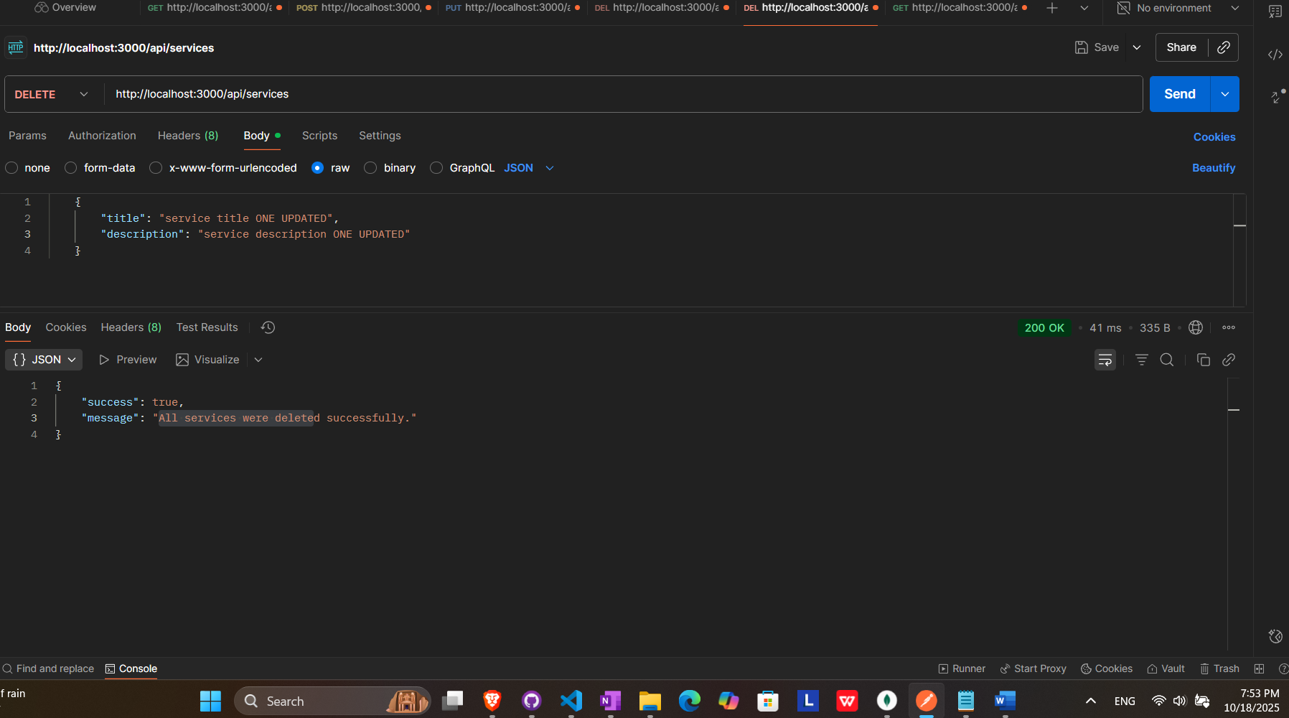

RESULT (ALL SERVICES DELETED)

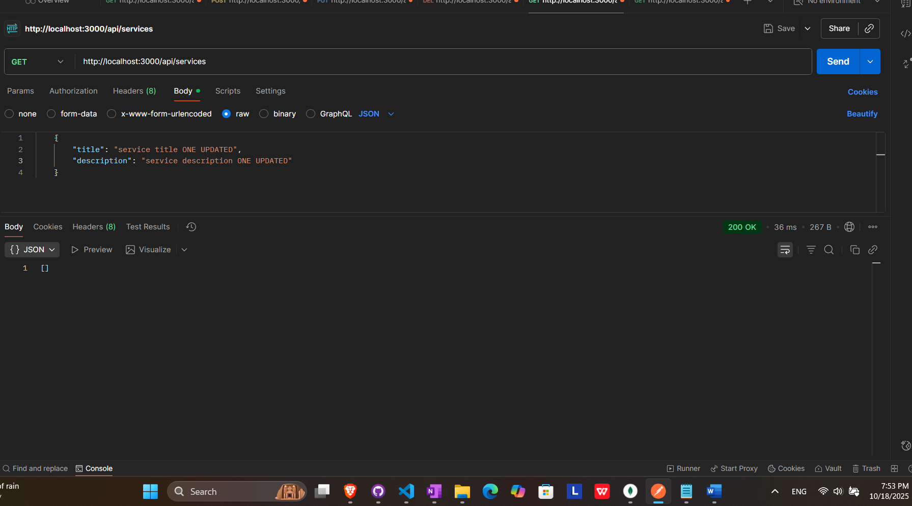

# Users endpoints

## Get all users

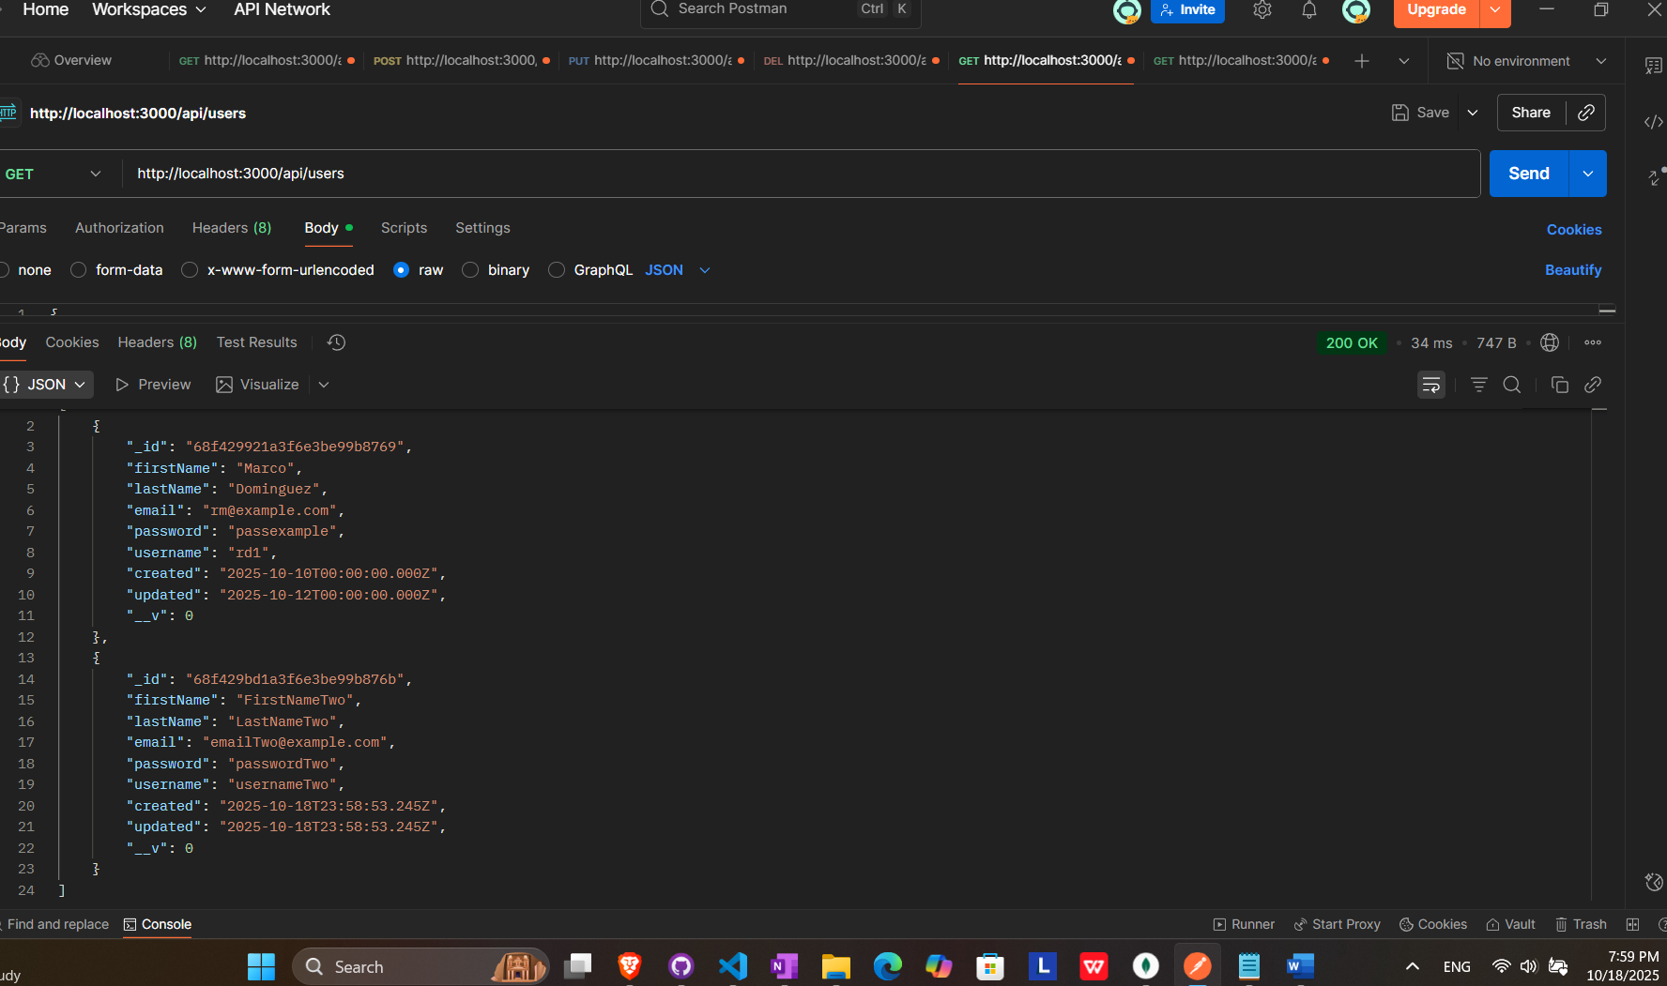

## Get User By Id

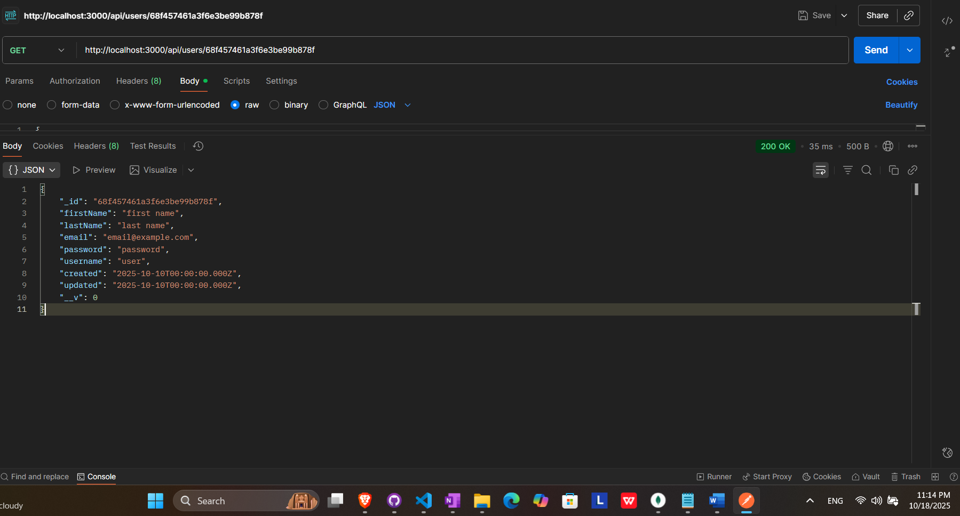

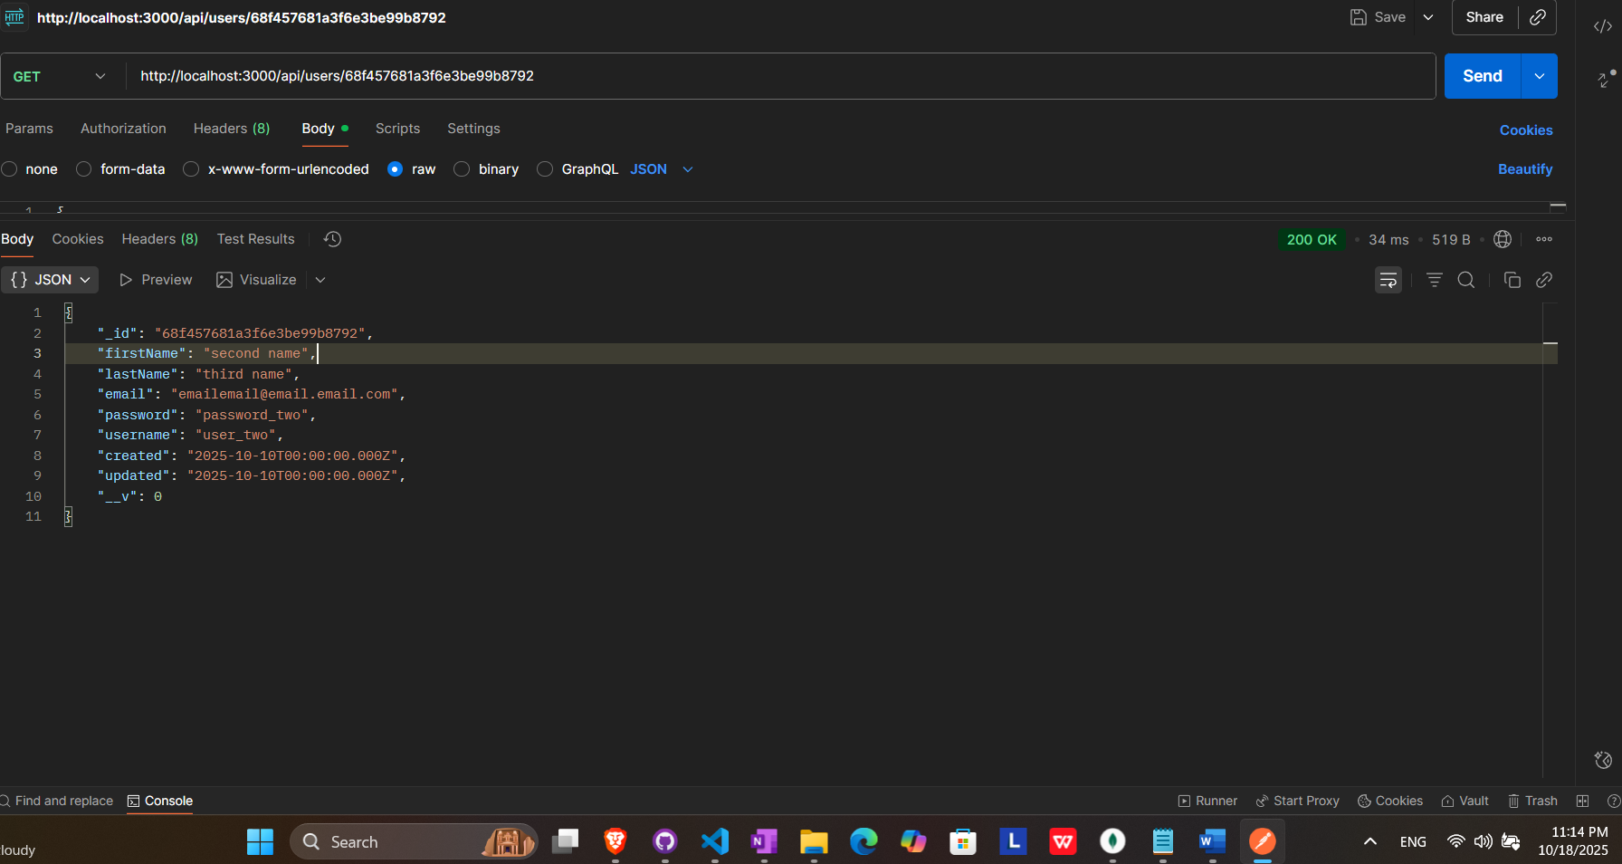

## Add new user

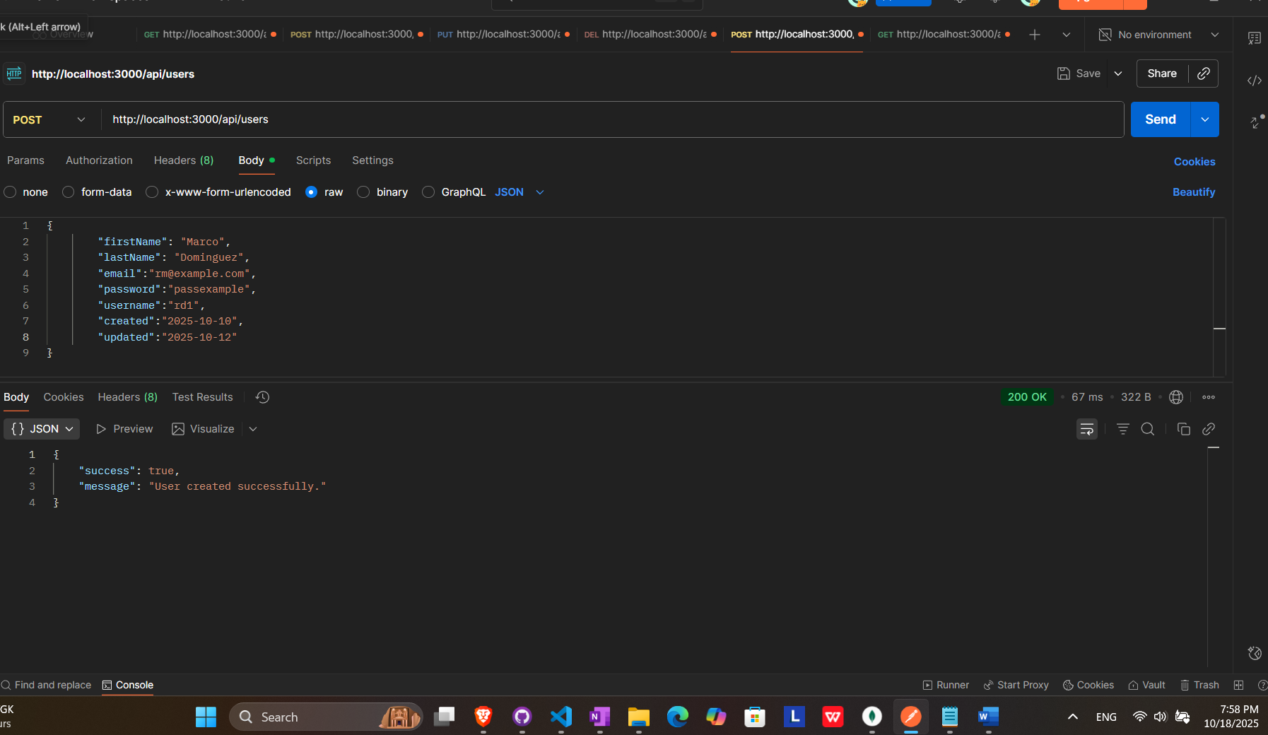

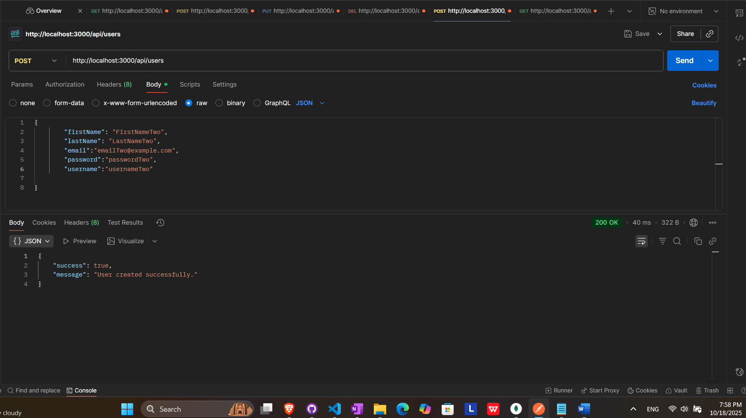

## Update user by id

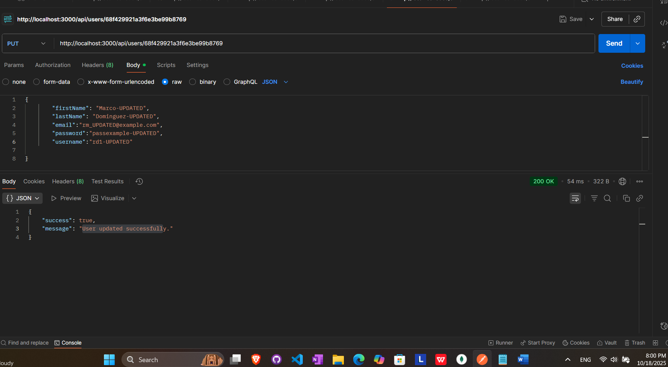

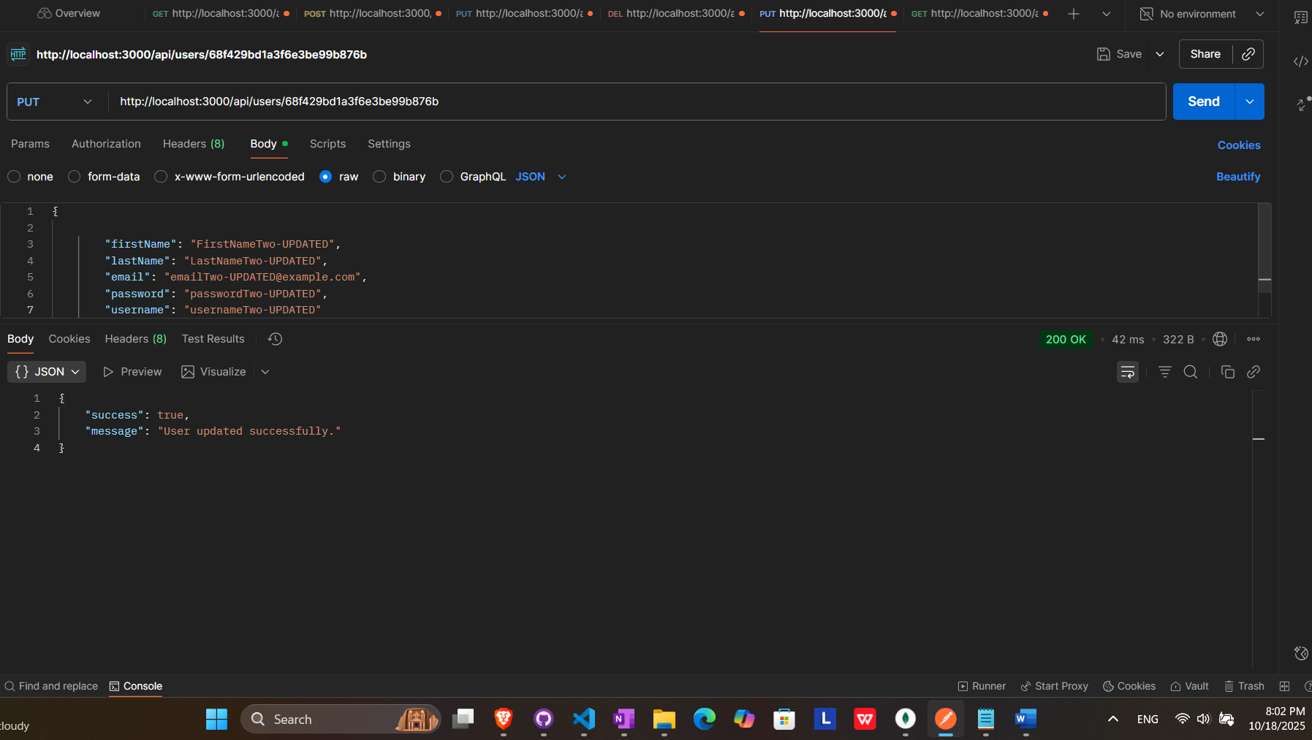

RESULT (ALL USERS UPDATED)

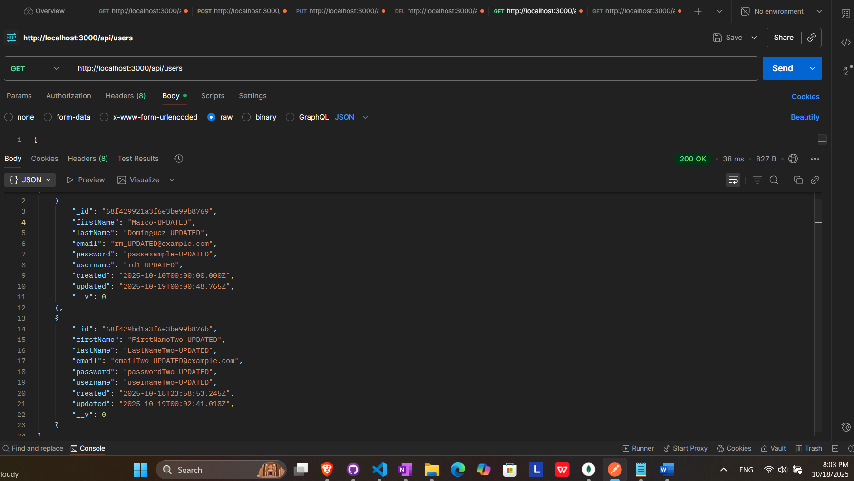

## Remove user by id

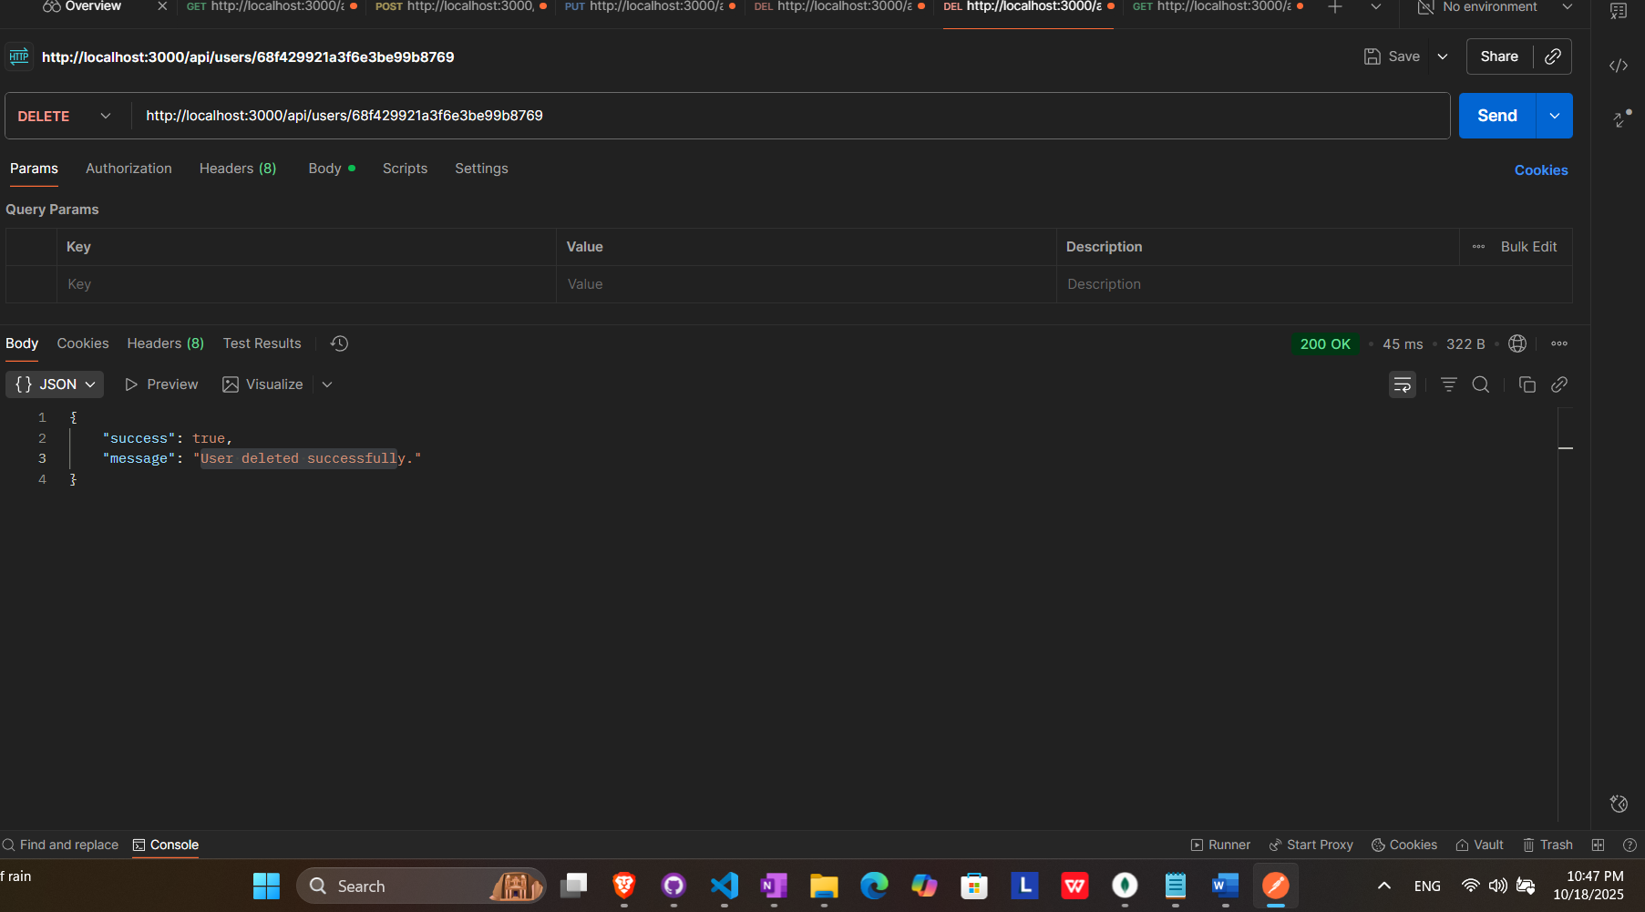

RESULT (USER DELETED)

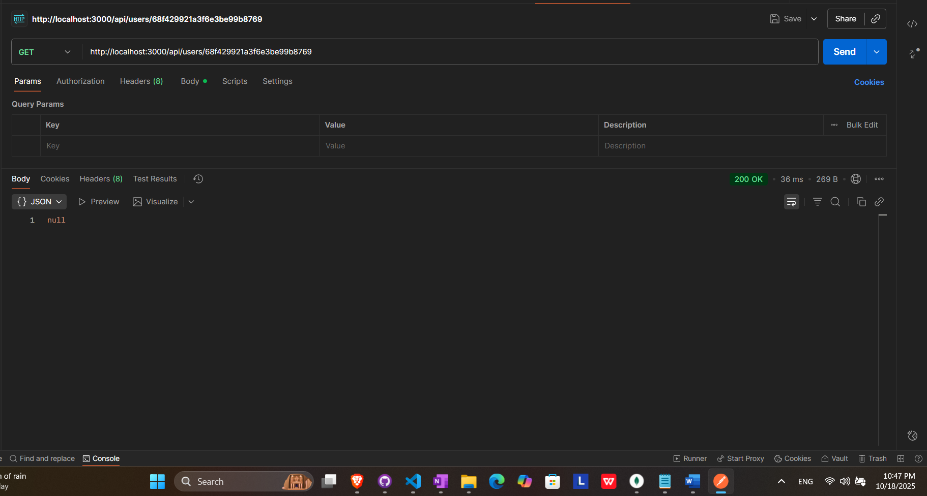

## Remove all users

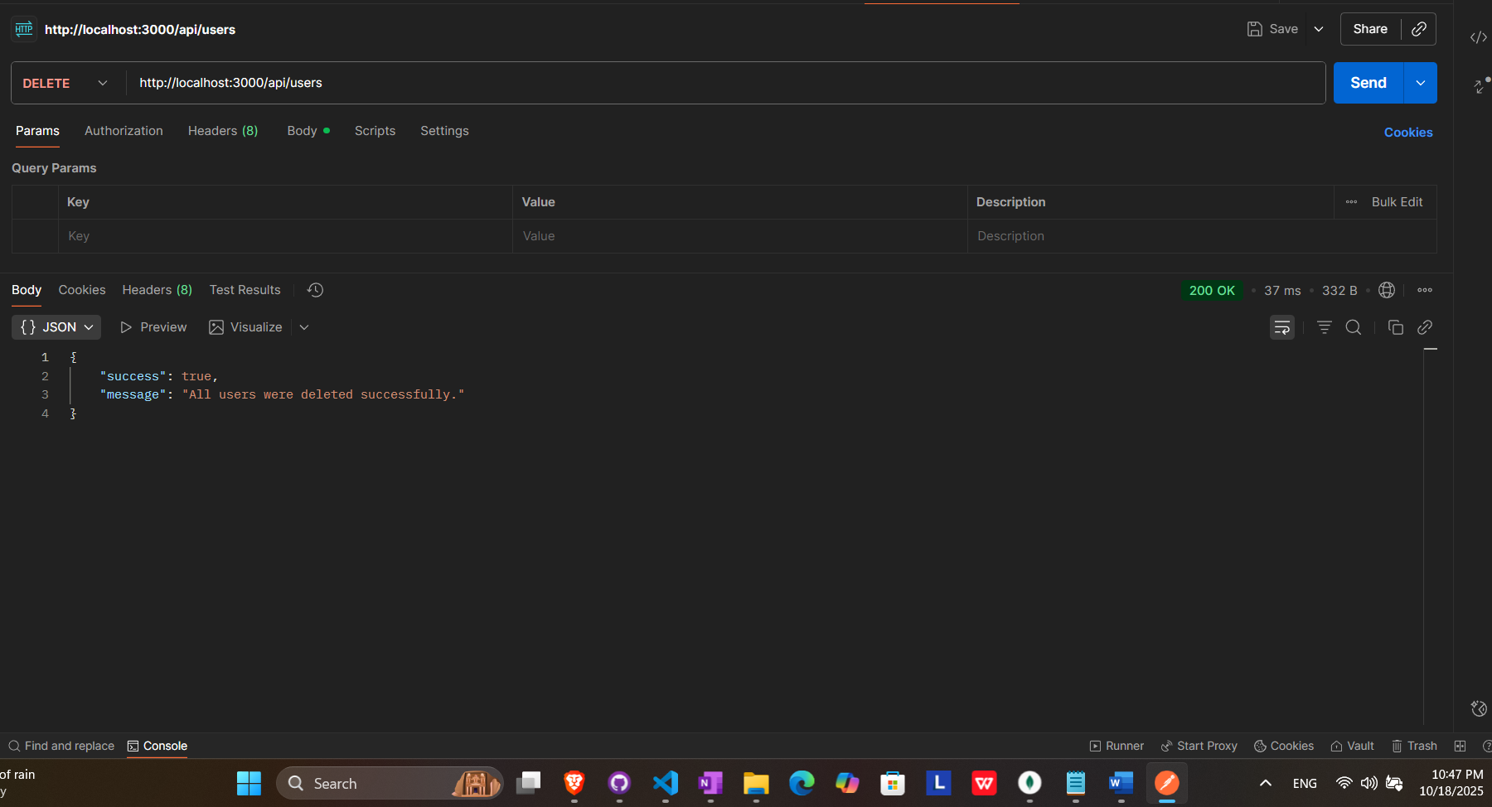

RESULTS (ALL USERS DELETED)

